|  |  |
| --- | --- |
|  | **VIỆN ĐÀO TẠO QUỐC TẾ FPT**  **LẬP TRÌNH VIÊN QUỐC TẾ** **FPT – APTECH**  **Centre Name: ACE-HCMC-2-FPT.**  **Address: 590 Cach Mang Thang 8, District 3, Ho Chi Minh City, Viet Nam.** |

Venus Restaurant

Design Document

|  |  |  |  |
| --- | --- | --- | --- |
| **Instructor:** | **Hoang Duc Quang** | | |
| **Batch No:** | T1.2206.M1 | | |
| **Group No:** | **Group 6** | | |
| **Students:** |  | **Full Name** | **Roll No.** |
|  | 1. | Phạm Hưng Quốc Vinh | Student1381861 |
|  | 2. | Hồ Đăng Việt Tiến | Student1384669 |
|  | 3. | Lâm Vĩnh Hào | Student1381859 |
|  | 4. | Nguyễn Hữu Phước | Student1384666 |

**Table of Contents**

**Acknowledgements 4**

**I. Introduction 6**

**II. Problem Definition: 6**

**III. Requirement Specification: 6**

1. Function Requirement Specification 6

1.1. Function of users: 6

1.2. Function of admins: 7

2. Non-functional Requirement Specifications 7

3. Model development 7

4. System Requirement Specifications 7

4.1. Server requirements: 7

4.2. Client requirements: 8

4.3. Development Software: 9

4.4. Technology: 9

**TASK SHEET REVIEW 1 10**

**I. Use Case: 12**

1. User: 12

1.1. User use case 12

1.2. Team use case 12

2. Admin: 13

2.1. Admin use case 13

**II. Sequence Diagram 13**

1. User Site: 13

1.1. Login 13

1.2. Signup 14

1.3. Create team 14

1.4. Edit team 15

1.5. Add team member 15

1.6. Remove team member 16

1.7. Add Task 16

1.8. Edit task 17

1.9. Upload/ Download document 18

1.10. Create/ Update/ Delete comment 19

1.11. Create./ Delete file submit 20

1.12. Create / Edit / Delete projects 21

1.13. Create / Edit / Delete milestones 22

2. Admin Site: 22

**III. Entity-Relationship Diagram 24**

**TASK SHEET REVIEW 2 25**

**I. Web: 27**

1. Admin Dashboard: 27

1.1. Login 27

1.2. Main Page 27

1.3. Create Admin 28

1.4. User List 29

1.5. Edit Personal Details 30

1.6. User/Details Details 31

1.7. Team List 32

1.8. Team Details 32

1.9. Project List 33

1.10. Project Documents 33

1.11. Project Milestones 33

1.12. Milestone Tasks 33

1.13. Tasks Details and Submits 33

1.14. Task Comments 33

2. User: 33

2.1. Login 33

2.2. Create Account 34

2.3. Create Team/ Go to team 35

2.4. Choose Project/ Create Project 36

2.5. Profile 37

2.6. Team Details 38

2.7. Create Project 40

2.8. Edit Project 41

2.9. Create Milestone 41

2.10. Edit Milestone 41

2.11. Task Board 41

2.12. Create Task 42

2.13. Edit Task 43

2.14. My Task 44

2.15. Documents 45

2.16. Team Member 46

**II. Android: 47**

1. User: 47

1.1. Opening Screen (Show logo) 47

1.2. Login 47

1.3. Sign up 47

1.4. Edit Account 47

1.5. Personal Team List 47

1.6. Create Team 47

1.7. Edit Personal Team 47

1.8. Project List 47

1.9. Milestones 47

1.10. Edit Milestones 47

1.11. Task Board 47

1.12. Create Task 47

1.13. Edit Task 47

1.14. My Task 47

1.15. Documents 47

1.16. Team Members 47

**TASK SHEET REVIEW 3 48**

# 

# Acknowledgements

The satisfaction that accompanies the successful completion of any task would be incomplete without the mention of those whose cooperation made it possible, whose constant guidance and encouragement crown all efforts with success.

We are grateful to our project guide Mr. Hoang Duc Quang for the guidance, inspiration, and constructive suggestions that helped us in the preparation of this project.

We also thank our team members who have helped in successful completion of the project.

REVIEW 1

# Introduction

First and foremost, we would like to express the deepest appreciation to our admirable instructor – Mr. Hoang Duc Quang During the time of the project, he continually and convincingly conveyed a spirit of excitement in regard to teaching. Without his guidance and persistent help this dissertation would not have been possible

Next, it would have been impossible to carry out and complete this project without the collaboration among our team members. Although we have gone through many obstacles during the project implementation, eventually we gained what we aimed at by our hard work, our strong commitment.

Finally, thanks to Aptech’s eProject team, we had a golden opportunity to apply what we have learnt into reality and gain hands-on experience which is essential for our future career.

# Problem Definition:

The primary objective of this project is to design and implement an integrated system that facilitates secure product information management through a web portal. The system aims to provide a seamless experience for users to book dishes and utilize an E-menu for ordering dishes. The platform should be accessible to both users and staff, offering distinct functionalities tailored to their respective needs. The successful implementation of this project will result in a comprehensive online catering reservation and ordering system. Users and staff will benefit from a streamlined process for booking buffet tickets, accessing the E-menu, and managing product information securely. The Venus Restaurant platform aims to enhance customer satisfaction through an efficient and modernized catering experience. This System will give the Restaurant management power and flexibility to manage the entire system from a single portal. The system allows the manager to keep track of available tables in the system as well as the reservation of tables and bill generation

**Features and Functionalities:**

* Product Information Management:

Enable secure and user-friendly updates of product information through a web browser.

* Food Ordering:

1. Allow users to order dishes through the online platform, providing a convenient reservation process.
2. The system should support the reservation of tables.
3. The receptionist should be able to search for available tables by date/time and reserve a table.
4. The system should allow customers to cancel their reservation.
5. The system should be able to send notifications whenever the reservation time is approaching

* E-menu for Ordering:

Implement an E-menu system accessible to both users and staff, enabling them to order dishes from a menu by the admin.

* Web-Based Platform:

Develop a web-based platform, named "Venus Restaurant," providing an intuitive interface for users to view, select, and order food products.A user-friendly website designed to meet customer demands with an extensive product selection and straightforward order placement.

* Mobile App**:**

Extend the platform's reach by integrating a mobile app, ensuring accessibility on mobile intelligent terminals for a seamless user experience.An integrated mobile application complementing the web portal, providing users with on-the-go access to the E-menu and other functionalities.

# Requirement Specification:

## **Function Requirement Specification**

### **Function of users:**

### **1.1. 1. Common User Functions:**

* User can login

### User can register account

* User can login
* User can logout
* User can view profile
* User can update profile

**1.1.2 Ordering:**

* Users can browse the available items and their details.
* Users can choose specific items
* Users can check their order history and details of orders.

### **1.1.3. Table Reservation:** Browse Available Tables: Users can view available tables for buffet dining.

### Select Table: Users can choose a specific table for their buffet reservation. Book Table: Users can book a table for a specific date and time. View Reservation History: Users can check their reservation history.

### **1.1.4. Blog:**

### Users can read posts about food in the restaurant and discount events.

### Users can search posts by keywords

### **1.1.5. Contact:**

### Users can send requirement or messages to admin.

### **1.2. Admin Functions: 1.2.1. Authentication:**

### Admins can log in and out of the system.

### **1.2.2. User Management:**

### Admins can view a list of all registered users.

### Admins can edit user profiles, including roles and permissions.

### Admins can suspend or activate user accounts.

### Admins can reset user passwords.

### **1.2.3. Table Management:**

### Admins can view the status of all restaurant tables. Manage Table Reservations: Admins can view, edit, and delete table reservations.

**1.2.4. Blog management:**

* Admins can view, edit, hidden and delete posts or discount events.

**1.2.5. Contact management:**

- Admins can view and reply contacts by emails.

**1.3. Staff Functions:  
1.3.1. Authentication:**

- Staff members can log in and out of the system.

**1.3.2. Table Service:**View Assigned Tables: Staff can view tables assigned to them for service.View Reservation Schedule: Staff can view the schedule of table reservations.  
The waiter should be able to create an order for a table and add meals for each seat.  
The receptionist should be able to search for available tables by date/time and reserve a table.

**1.4. Chef Functions:**- Chefs can filter /Search dishes in orders - Chefs can view a list of dishes in orders.  
- Chefs can update the status of dishes in an order.

## **Non-functional Requirement Specifications**

* Good user interface and experience.
* Clean code
* Improve performance
* Security

## **Model development**

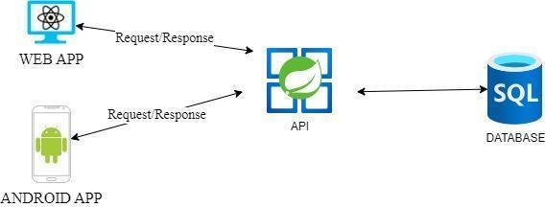

## **System Requirement Specifications**

### Server requirements: Hardware:

|  |  |
| --- | --- |
| Component | Requirement |
| CPU | Processor type: Apple M1 chip  Recommended: Multi-core processor, 64-bit  Processor speed: Recommended: 3.0 GHz or faster |
| OS | macOS  Microsoft Windows 10 or higher with IIS |
| Memory (RAM) | RAM:  Minimum: 512 MB  Recommended: 2 GB or more |
| Hard Drive | Free space:  Minimum: 200 MB  Recommended: 20 GB or more  Maximum: Operating system maximum |

Software:

|  |  |
| --- | --- |
| Component | Requirement |
| Spring framework | Spring 6.0.2 |
| RDBMS | Microsoft SQL |

## 

### Development Software:

* Microsoft SQL
* Visual Studio Code

### Technology:

* Java
* Spring boot
* API mobile
* ReactJS
* Recapcha Google
* Paypal/VNpay

# TASK SHEET REVIEW 1

|  |  |  |  |  |  |  |  |
| --- | --- | --- | --- | --- | --- | --- | --- |
| **Project Ref. No.** | | **Project Title:** | **Activity Plan** **Prepared** **By:** | **Date of Preparation of Activity Plan:** | | | |
| **Sr.No.** | **Task** | **Actual Start** **Date** | **Actual** **Days** | **Team** **Mate** **Names** | **Status** |
| 1 | Acknowledgement | Venus Restaurant | All member |  | 1 | All | Completed |
| 2 | Problem Definition |  | 1 | All | Completed |
| 3 | Requirement Specification |  | 1 | All | Completed |

# 

|  |  |
| --- | --- |
| **Date:** | |
| Signature of Instructor:  **Mr. Hoang Duc Quang** | Signature of Team Leader:  **Mr. Ho Dang Viet Tien** |

REVIEW 2

# Use Case:

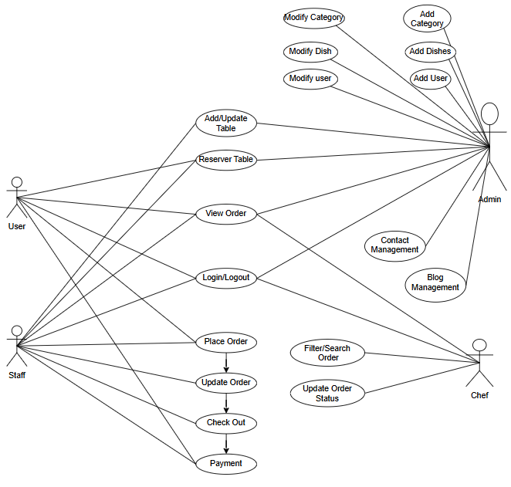

* + 1. **Blog management:**

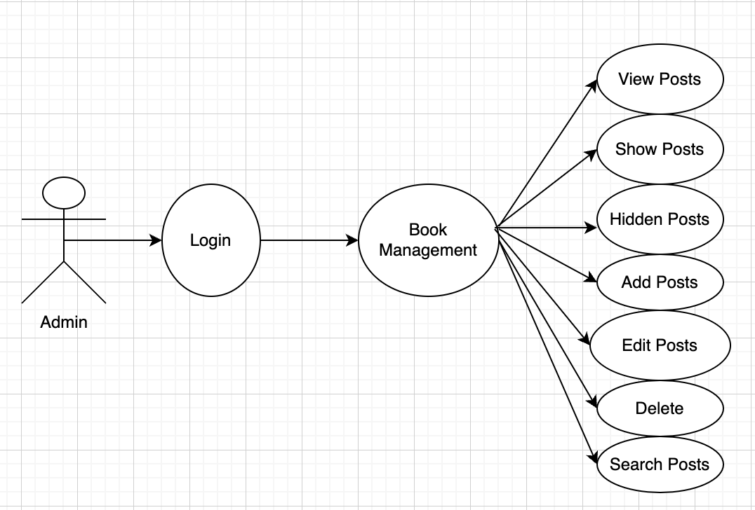

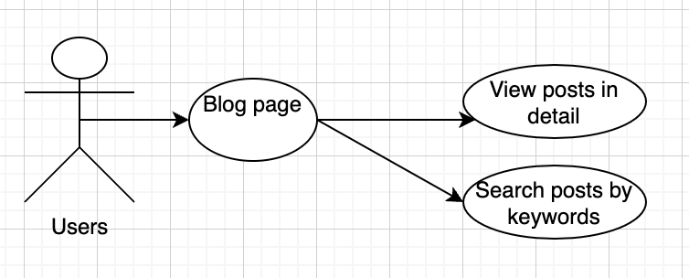

* + 1. **Contact management:**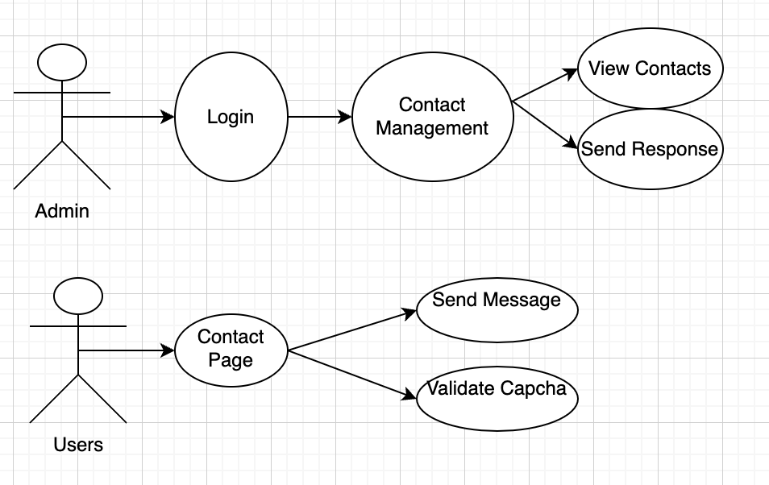
    2. **User Function**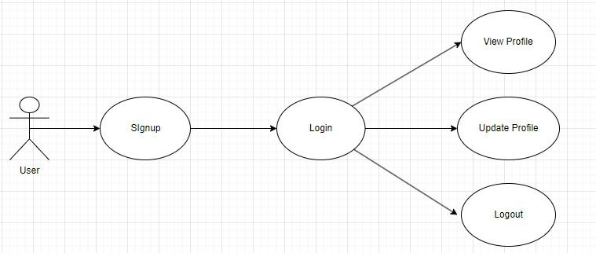
    3. **Dish Management**

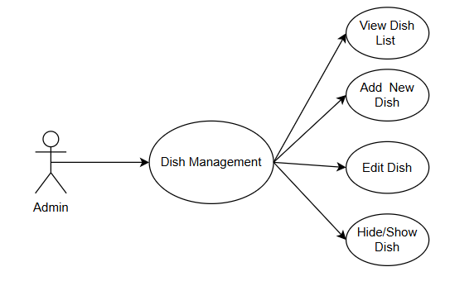

* + 1. **User Place Order**

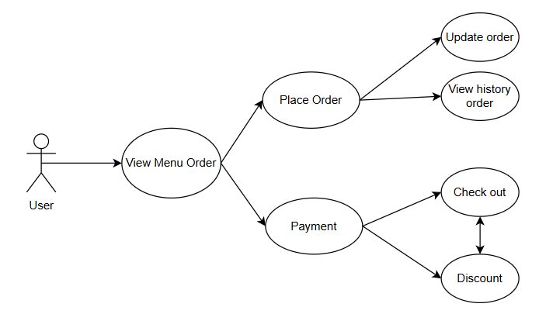

* + 1. **Staff Management**

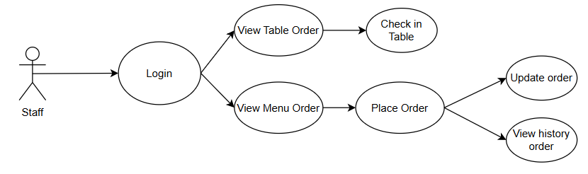

* + 1. **Chef Management**

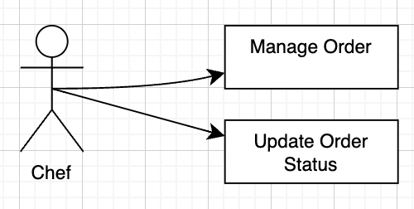

# Sequence Diagram

## **User Site:**

### Login

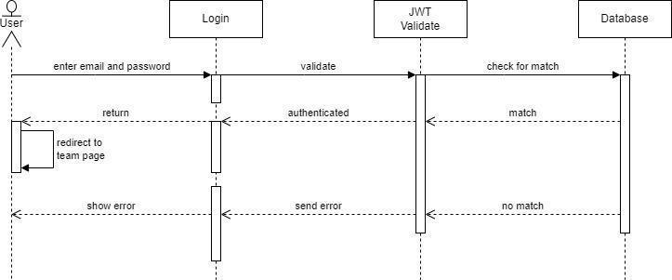

|  |  |  |
| --- | --- | --- |
| Author | Hao | |
| Use Case Name | User Login | |
| Actors | User | |
| Description | The User submits login credentials (email and password), which are validated. Upon successful validation, the user is redirected to the team page. If validation fails, an error message is displayed. | |
| Requirements | * Access to the login page with a form. * Active internet connection. | |
|  | Actor Actions | System Responses |
| **Basic Flow** | 1. User enters email and password and submits the form. | 1. System receives the login credentials. 2. System forwards the credentials to the Login service. 3. Login service sends the credentials to the JWT Validate service. 4. JWT Validate service checks the credentials against the database. 5. If the credentials match, the JWT Validate service returns an authenticated response to the Login service. 6. Login service redirects the user to the team page. 7. If the credentials do not match, the JWT Validate service returns an error response to the Login service. 8. Login service displays an error message to the user. |
| **Alternate Flow** | 1. User enters email and password and submits the form. | 1. System receives the login credentials. 2. System forwards the credentials to the Login service. 3. Login service sends the credentials to the JWT Validate service. 4. JWT Validate service checks the credentials against the database. 5. If the credentials do not match, the JWT Validate service returns an error response to the Login service. 6. Login service displays an error message to the user. |

### Signup

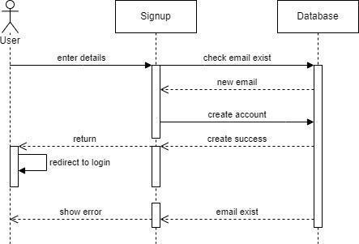

|  |  |  |
| --- | --- | --- |
| Author | Hao | |
| Use Case Name | Signup | |
| Actors | User, System, Database | |
| Description | The User signs up for a new account by providing their details. The System checks if the email already exists in the Database. If the email is new, the System creates the account and redirects the User to the login page. If the email exists, an error message is displayed to the User. | |
| Requirements | * Access to the signup page. * Active internet connection. | |
|  | Actor Actions | System Responses |
| **Basic Flow:** | 1. User enters signup details. 2. User submits the signup form. | 1. The System receives the signup form submission. 2. The System checks if the email already exists in the Database  * If the email does not exist: * The System creates the account in the Database. * The System sends a success response to the User. * The System redirects the User to the login page. * If the email exists: * The System sends an error response to the User. * The System displays an error message to the User. |

### User VIew Profile

|  |  |  |
| --- | --- | --- |
| Author | Hao | |
| Use Case Name | User View Profile | |
| Actors | User | |
| Description | This use case describes the process by which a user requests to view their profile details. The system retrieves the necessary information from the database and displays it to the user. | |
| Requirements | * User must be logged into the system. * Access to the profile view page. * Active internet connection. | |
|  | Actor Actions | System Responses |
| Basic Flow | 1. The User navigates to their profile page. 2. The User requests to view their profile details. | 1. The View Profile component receives the user's request. 2. The View Profile component sends a request to the Database to retrieve the user's email. 3. The Database retrieves the email and sends it back to the View Profile component. 4. The View Profile component sends a request to the Database to retrieve the user's address. 5. The Database retrieves the address and sends it back to the View Profile component. 6. The View Profile component sends a request to the Database to retrieve the user's phone number. 7. The Database retrieves the phone number and sends it back to the View Profile component. 8. The View Profile component compiles the retrieved profile details (email, address, phone number). 9. The View Profile component displays the complete profile details to the User. |

### 

### User Update Profile

|  |  |  |
| --- | --- | --- |
| Author | Hao | |
| Use Case Name | User Update Profile | |
| Actors | User, Update Profile System, Database | |
| Description | The User requests to update their profile. The system retrieves existing profile details from the Database, displays them to the User, and allows the User to update their phone number and address. The updated information is saved back to the Database. | |
| Requirements | * Access to the profile update page. * Active internet connection. | |
|  | Actor Actions | System Responses |
| Basic Flow | 1. User requests to update their profile. 2. User views the retrieved profile details. 3. User updates their phone number and address. | 1. The Update Profile System receives the profile update request. 2. The Update Profile System retrieves the User’s email and address from the Database. 3. The Update Profile System displays the retrieved profile details to the User. 4. The Update Profile System displays the retrieved profile details to the User. 5. The Update Profile System updates the phone number and address in the Database. 6. The Update Profile System returns the updated profile to the User. |

### Order menu

|  |  |  |
| --- | --- | --- |
| Author | VInh | |
| Use Case Name | Order Menu | |
| Actors | User, Chef, Staff | |
| Description | The User places an order through the Menu System. The Chef prepares the order, and Staff serves the order to the User. The Menu System updates and checks the order status throughout the process. | |
| Requirements | * Access to the menu system. * Active internet connection (if the system is online). | |
|  | Actor Actions | System Responses |
| **Basic Flow** | 1. User checks the table. 2. User places an order through the Menu System. | 1. The Menu System receives the order and updates the order status. 2. The Menu System sends the order details to the Chef. 3. The Chef updates the Menu System once the order is checked. 4. The Chef sends a callback to the Menu System after order preparation. 5. The Menu System notifies the Staff. 6. The Staff serves the order to the User. |

### 

### Payment

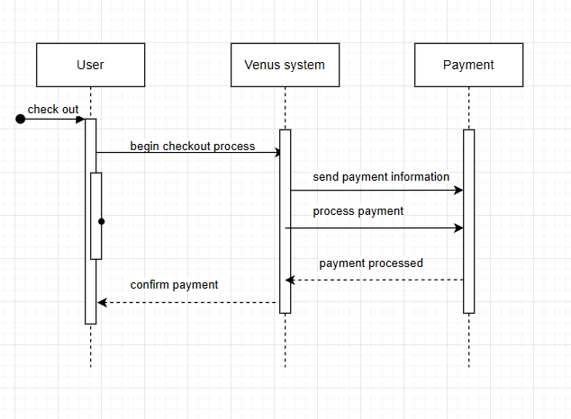

|  |  |  |
| --- | --- | --- |
| Author | Vinh | |
| Use Case Name | Payment | |
| Actors | Staff | |
| Description | The use case describes the process of a user making a payment through the Venus system. The payment information is sent to an external Payment system for processing, and the user receives confirmation upon successful completion. | |
| Requirements | * User access to the Venus system. * Internet connectivity. * Integration with an external Payment system. | |
|  | Actor Actions | System Responses |
| Basic Flow | 1. **The user initiates the checkout process by selecting the checkout option.** 2. **The Venus system prepares the necessary payment information.** 3. **The Payment system receives and processes the payment information.** 4. **The Venus system receives the payment confirmation from the Payment system.** | 1. The Venus system starts the checkout process. 2. The Venus system sends the payment information to the Payment system. 3. The Payment system processes the payment and sends a confirmation back to the Venus system 4. The Venus system sends a payment confirmation to the user. |
|  |  |  |
| Alternate Flow | 1. **Condition: If the user decides to cancel the checkout process before completing the payment.** 2. **Actor Action: The user cancels the checkout process.** 3. **System Response: The Venus system terminates the checkout process and returns the user to the previous state or page.** | 1. **Condition:** If the payment processing fails (e.g., due to insufficient funds, network issues, or invalid payment details). 2. **Actor Action:** The Payment system sends a failure notification to the Venus system. 3. **System Response:** The Venus system informs the user of the payment failure and may prompt the user to retry or use a different payment method. |

**1.8 Contact page:**  
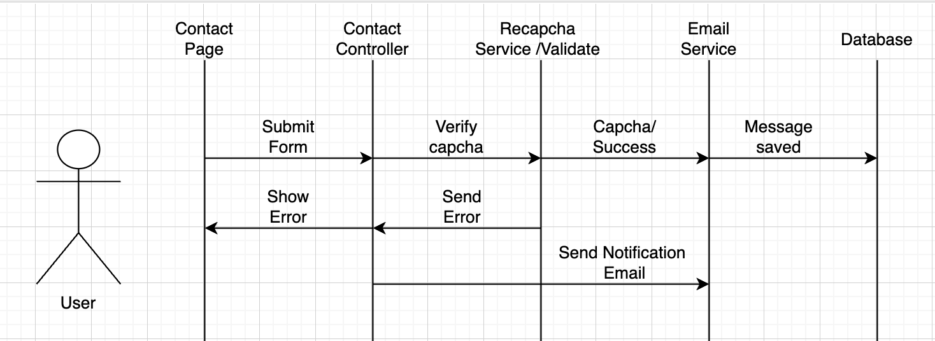

|  |  |  |
| --- | --- | --- |
| Author | Vinh | |
| Use Case Name | Submit Contact Form | |
| Actors | Users and Clients | |
| Description | The User submits a contact form, which is then verified for captcha and saved to the database. A notification email is also sent upon successful submission. | |
| Requirements | Access to the contact page with a form.  Active internet connection. | |
|  | Actor Actions | System Responses |
| Basic flow | 1. User fills out the contact form and submits it. 2. System forwards the submission to the Contact Controller. 3. Contact Controller sends the form data to the Recaptcha Service for validation. 4. Recaptcha Service returns the verification result. 5. Contact Controller sends an error message to the Contact Page. 6. If verification is successful, the Contact Controller proceeds to save the form data. 7. Email Service saves the message to the database. 8. Email Service sends a notification email. | 1. System receives the form submission on the Contact Page. 2. Contact Controller processes the form data 3. Recaptcha Service verifies the captcha. 4. If verification fails, an error is sent back to the Contact Controller. 5. Contact Page displays the error to the User. 6. Contact Controller forwards the data to the Email Service. 7. System confirms message saved. 8. User receives a success message on the Contact Page. |

**1.9 Blog Page:**

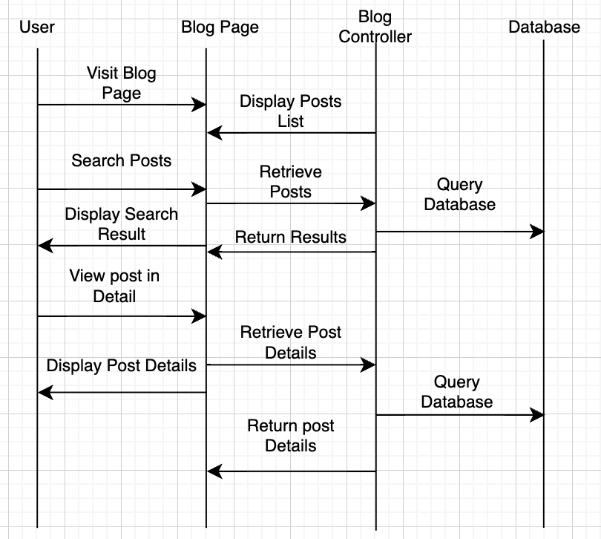

|  |  |  |
| --- | --- | --- |
| Author | Vinh | |
| Use Case Name | View and Search Blog Posts | |
| Actors | User and Client | |
| Description | This sequence diagram illustrates the process of a user viewing and searching for blog posts in the system. | |
| Requirements |  | |
|  | Actor Actions | System Responses |
| Basic flow | 1. Clients and Users navigates to the Blog Page.  3. User views a specific blog post in detail.  7. User searches for blog posts using keywords. | 2. The system displays the blog page with a list of blog posts.  4. The system retrieves the post details from the database.  5. The database sends the post details to the system.  6. The system displays the post details to the user.  8. The system processes the search request and queries the database.  9. The database returns the search results to the system.  10. The system displays the search results to the user. |

1.10 Booking Table Page:

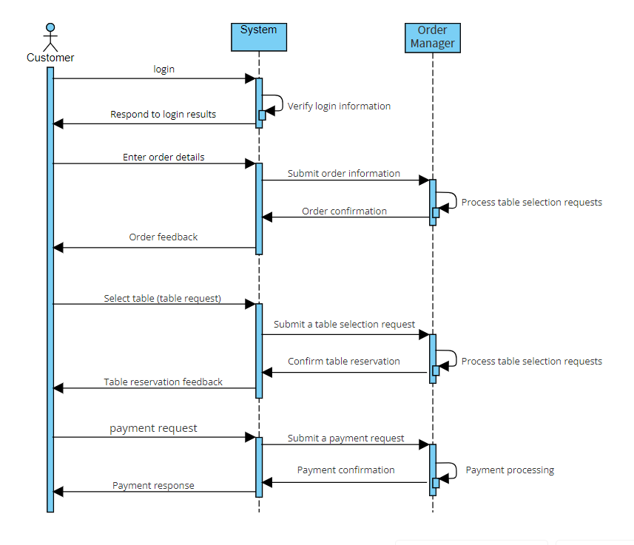

|  |  |  |
| --- | --- | --- |
| Author | Phuoc | |
| Use Case Name | Booking table | |
| Actors | Customer | |
| Description | This sequence diagram depicts the customer logging in, entering order information, selecting a table, and paying | |
| Requirements | Customers must have a registered account | |
|  | Actor Actions | System Responses |
| Basic flow | 1.Customers log in with email and password.  3.Customers enter personal information and request.  7. The customer sends a payment request | 2. The system responds to login results.  4. The system sends order information to order Manager.  5.The system displays notifications to customers  6. The system displays the post details to the user.  8. System Send payment request Payment Manager.  9. Payment confirmation.  10. The system sends the display to the customer |

## **Admin Site:**

* 1. Create admin/staff

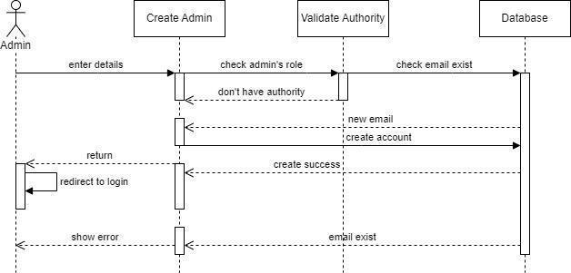

|  |  |  |
| --- | --- | --- |
| Author | Hao | |
| Use Case Name | Create Admin/Staff | |
| Actors | Admin | |
| Description | This use case describes the process where an admin user creates a new admin or staff account. The system validates the admin's authority, checks if the email exists in the database, and creates the account if all validations pass. | |
| Requirements | * The admin must be logged into the system. * The admin must have the necessary permissions to create new accounts. * Active internet connection. | |
|  | Actor Actions | System Responses |
| Basic Flow | 1. The Admin enters the details for the new admin/staff account and submits the form. | 1. Check Admin's Role 2. Check Email Existence 3. Create Account |

* 1. Create & Update Menu

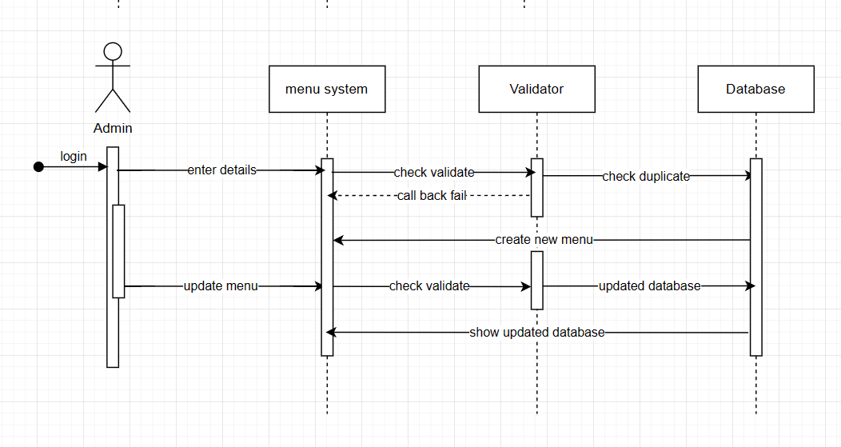

|  |  |  |
| --- | --- | --- |
| Author | Tien | |
| Use Case Name | Create and Update Menu Dish | |
| Actors | Admin | |
| Description | This use case describes the process where an admin creates a new dish for the menu. The system validates the admin's authority, checks if the email exists in the database, and creates the account if all validations pass. | |
| Requirements | ● The admin must be logged into the system.  ● The admin must have the necessary permissions to create new dish.  ● Active internet connection. | |
|  | Actor Actions | System Responses |
| Basic Flow | The Admin enters the details for the new dish and submits the form. | 1. Check Admin's Role 2. Check duplication 3. Create dish |

* 1. Income Check/Export

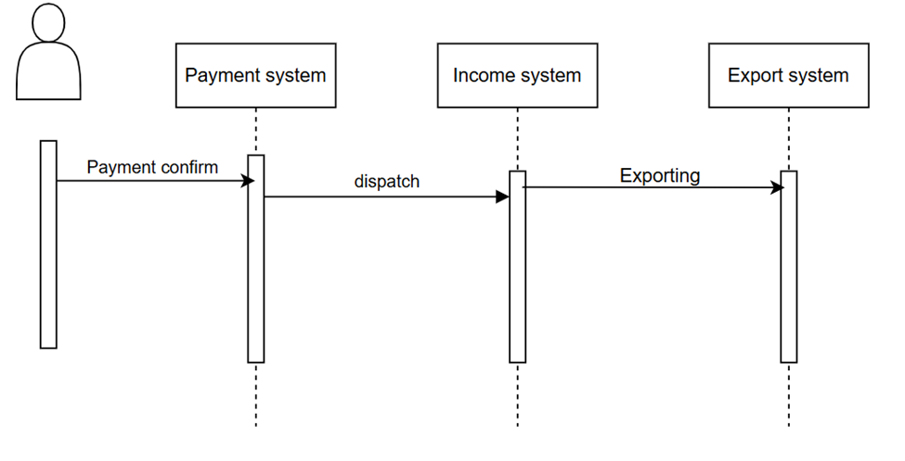

|  |  |  |
| --- | --- | --- |
| Author | Tien | |
| Use Case Name | Income Check/Export | |
| Actors | User | |
| Description | The user confirms the payment, initiating a series of interactions between the payment system, income system, and export system to complete the transaction. | |
| Requirements | ● The admin must be logged into the system.  ● The admin must have the necessary permissions to create new dish.  ● Active internet connection. | |
|  | Actor Actions | System Responses |
| Basic Flow | - User confirms the payment  - Payment system dispatches the payment details.  - Income system processes the dispatch and prepares for exporting. | - Payment system processes the payment confirmation  - Income system receives the dispatch  - Export system receives the exporting request and completes the export process |

2.3 Reservation

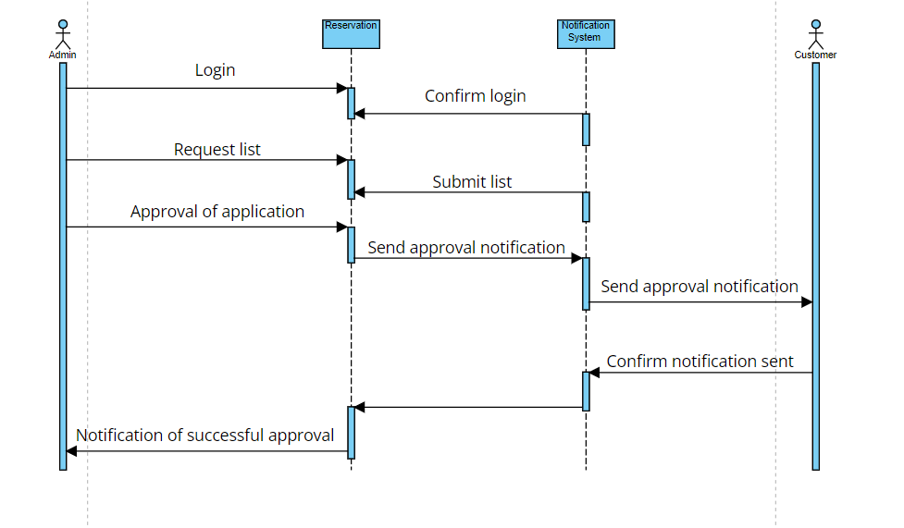

|  |  |  |
| --- | --- | --- |
| Author | Phuoc | |
| Use Case Name | Reservation | |
| Actors | Admin | |
| Description | This use case describes how the admin must log in and then go to the reservation page to approve the customer's order and send them an email notification. | |
| Requirements | * The admin must be logged into the system. * Active internet connection. | |
|  | Actor Actions | System Responses |
| Basic Flow | 1. The Admin enters the details for the new admin/staff account and submits the form. | 1. Check Admin's Role 2. Check Email Existence 3. Create Account |

* 1. **Blog management**

**Create New Blog**

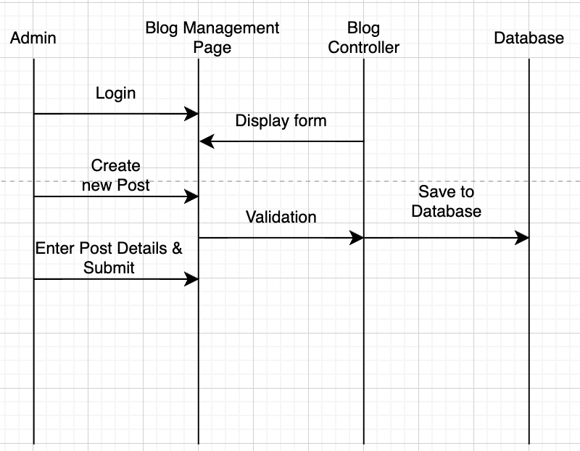

**Show/Hide New Blog**

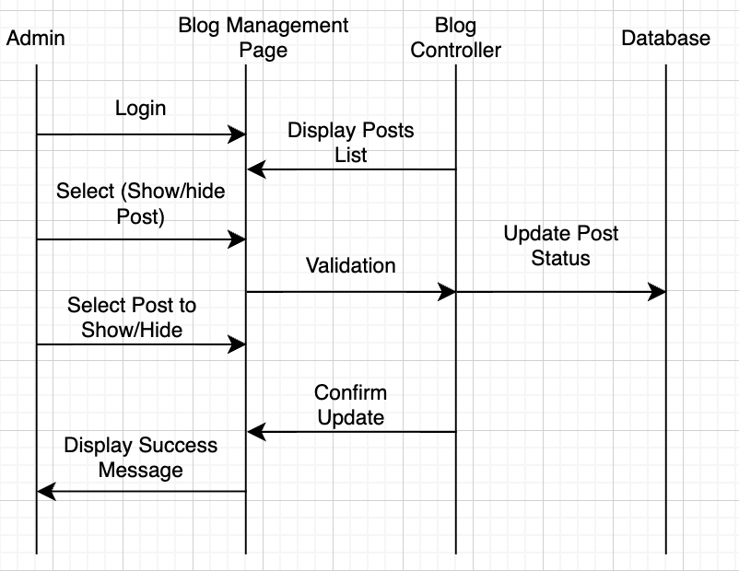

|  |  |  |  |  |
| --- | --- | --- | --- | --- |
| Author | | Vinh | | |
| Use Case Name | | Blog Management | | |
| Actors | | Admin | | |
| Description | | This sequence diagram illustrates the process of an admin managing blog posts, including adding, hiding, showing, and deleting posts in the system. | | |
| Requirements | | Admin must be logged in to manage blog posts. | | |
|  | | Actor Actions | | System Responses |
| Basic flow | 1. Admin logs in to the Blog Management System.  3. Admin adds a new blog post.  7. Admin views the list of blog posts.  11. Admin hides a blog post.  15. Admin shows a hidden blog post.  19. Admin deletes a blog post. | | 4. The system sends the post data to the database to be saved.  5. The database confirms the post has been saved and sends a confirmation back to the system.  6. The system confirms the addition to the admin.  8. The system retrieves the list of posts from the database.  9. The database sends the list of posts to the system.  10. The system displays the list of posts to the admin.  12. The system updates the post status to hidden in the database.  13. The database confirms the status change and sends a confirmation back to the system.  14. The system confirms the status change to the admin.  16. The system updates the post status to visible in the database.  17. The database confirms the status change and sends a confirmation back to the system.  18. The system confirms the status change to the admin.  20. The system removes the post from the database. | |

* 1. **Chef Management**

**Change Order’s Status**

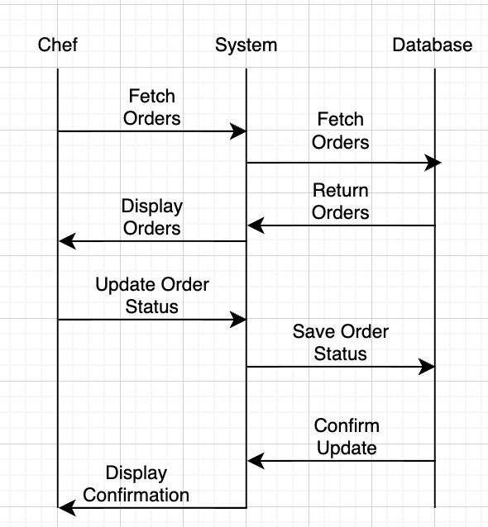

|  |  |  |
| --- | --- | --- |
| Author | Vinh | |
| Use Case Name | Manage Order – Change Order’s Status | |
| Actors | Chef | |
| Description | The Chef updates the order’s status through the system. | |
| Requirements | Login as Chef | |
|  | Actor Actions | System Responses |
| Basic flow | 1. Chef logs into the system. 2. Chef selects an order from the list. 3. Chef updates the order status and clicks the update button. 4. System confirms the status update. | 1. System verifies the Chef's credentials. 2. System displays the order details. 3. System saves the updated status to the database. 4. Display confirmation message to Chef. |
| Alternative flow | 5.Clicks on “Order detail” | 6.View detail other dishes in order . |

* 1. **Contact management**

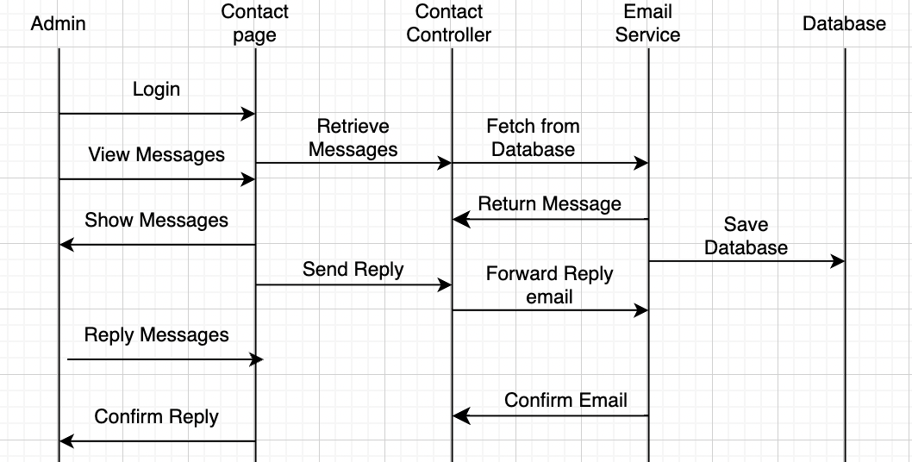

|  |  |  |
| --- | --- | --- |
| Author | Vinh | |
| Use Case Name | Contact Management – Read and Reply to Messages | |
| Actors | Admin | |
| Description | Admin logs in, reads user messages, and replies to them. The reply is sent to the user's email. | |
| Requirements | Login as Admin | |
|  | Actor Actions | System Responses |
| Basic flow | 1. Admin logs in.  2. Admin selects to view messages.  3. Admin selects a specific message to read.  4. Admin writes a reply and submits it.  5. Admin views a confirmation message. | 1. The system verifies login credentials.  2. The system retrieves messages from the database and displays them to the admin.  3. The system displays the content of the selected message.  4. The system forwards the reply to the email service, which sends the email to the user.  5. The system confirms that the reply has been sent successfully. |

# Entity-Relationship Diagram

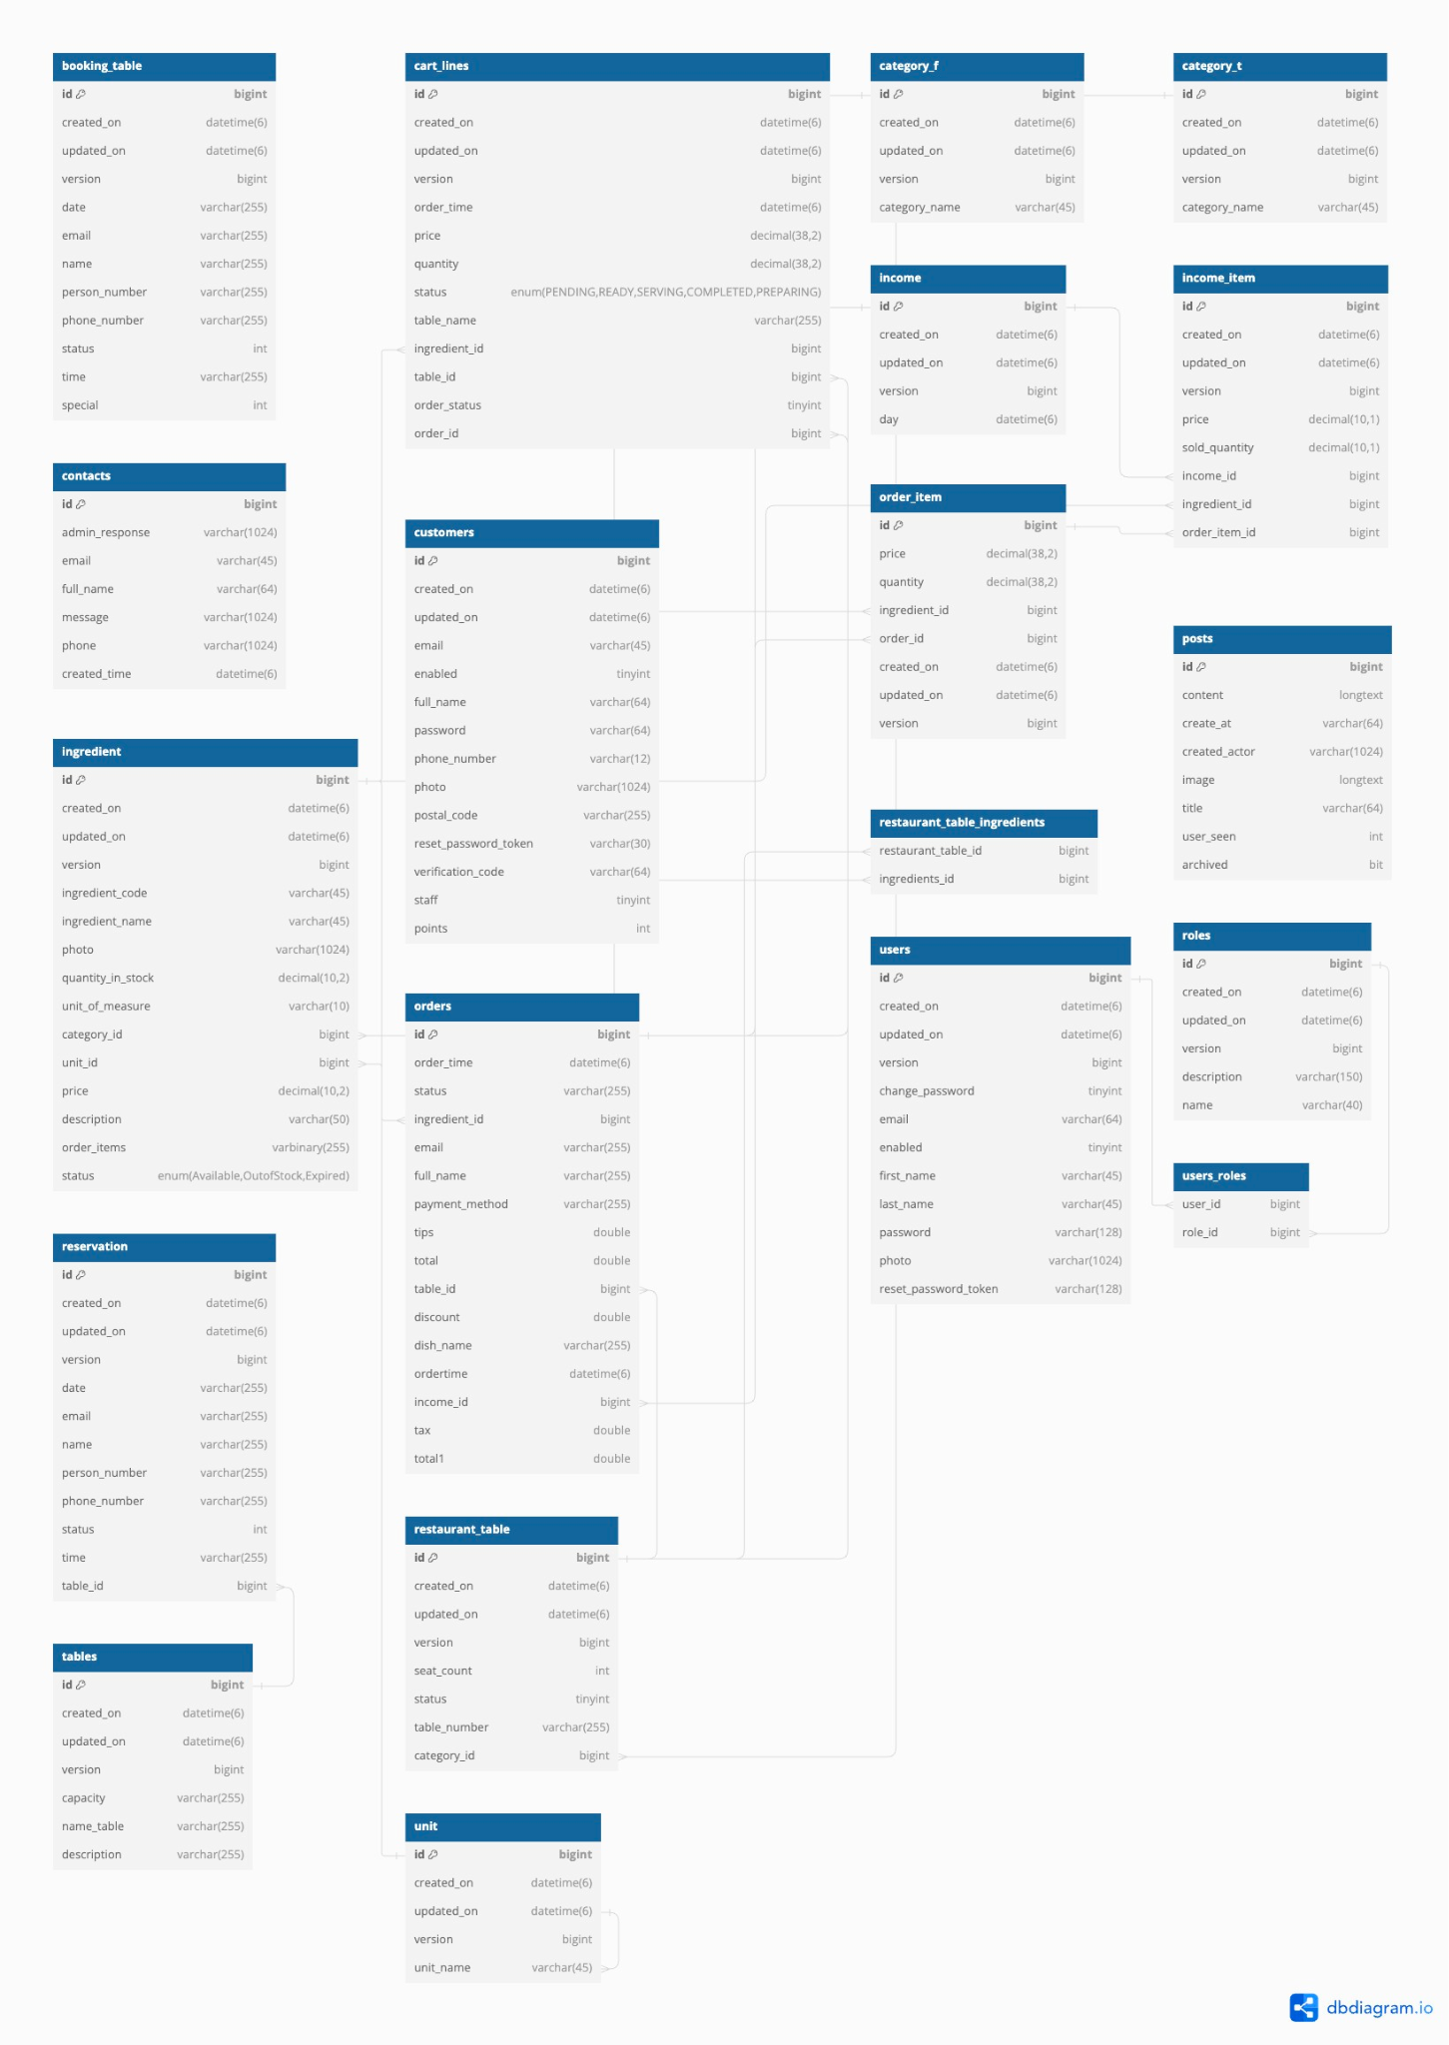

# TASK SHEET REVIEW 2

|  |  |  |  |  |  |  |  |
| --- | --- | --- | --- | --- | --- | --- | --- |
| **Project Ref. No.** | | **Project Title:** | **Activity Plan** **Prepared** **By:** | **Date of Preparation of Activity Plan:** | | | |
| **Sr.No.** | **Task** | **Actual Start** **Date** | **Actual** **Days** | **Team** **Mate** **Names** | **Status** |
| 1 | Use Case | Venus Restaurant | All member |  | 3 | All | Completed |
| 2 | Sequence Diagram |  | 3 | All | Completed |
| 3 | Entity-Relationship Diagram |  | 3 | All | Completed |

# 

|  |  |
| --- | --- |
| **Date:** | |
| Signature of Instructor:  **Mr. Hoang Duc Quang** | Signature of Team Leader:  **Mr. Ho Dang Viet Tien** |

REVIEW 3

# Web:

## **Admin Dashboard:**

### Login

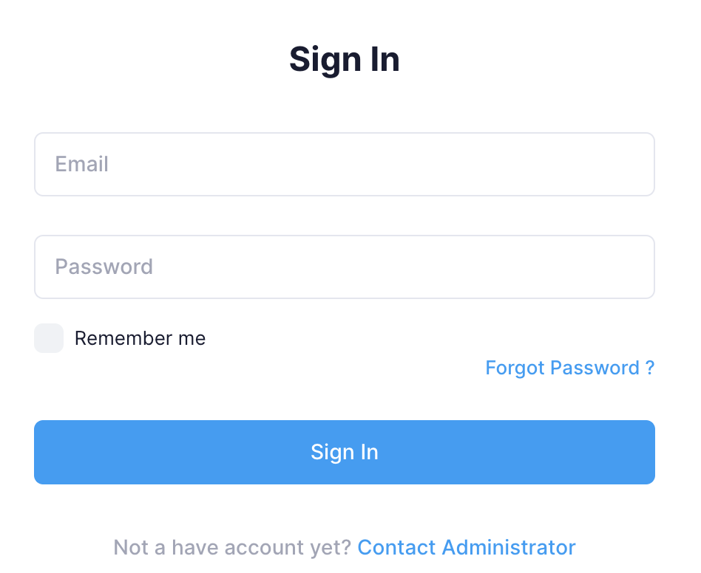

|  |  |  |
| --- | --- | --- |
| **N.o** | **Name** | **Action** |
| 1. | Login form | Admin input email and password |
| 2 | Login button | Redirect to main admin page if email and password are valid and available in database |

### Main Page

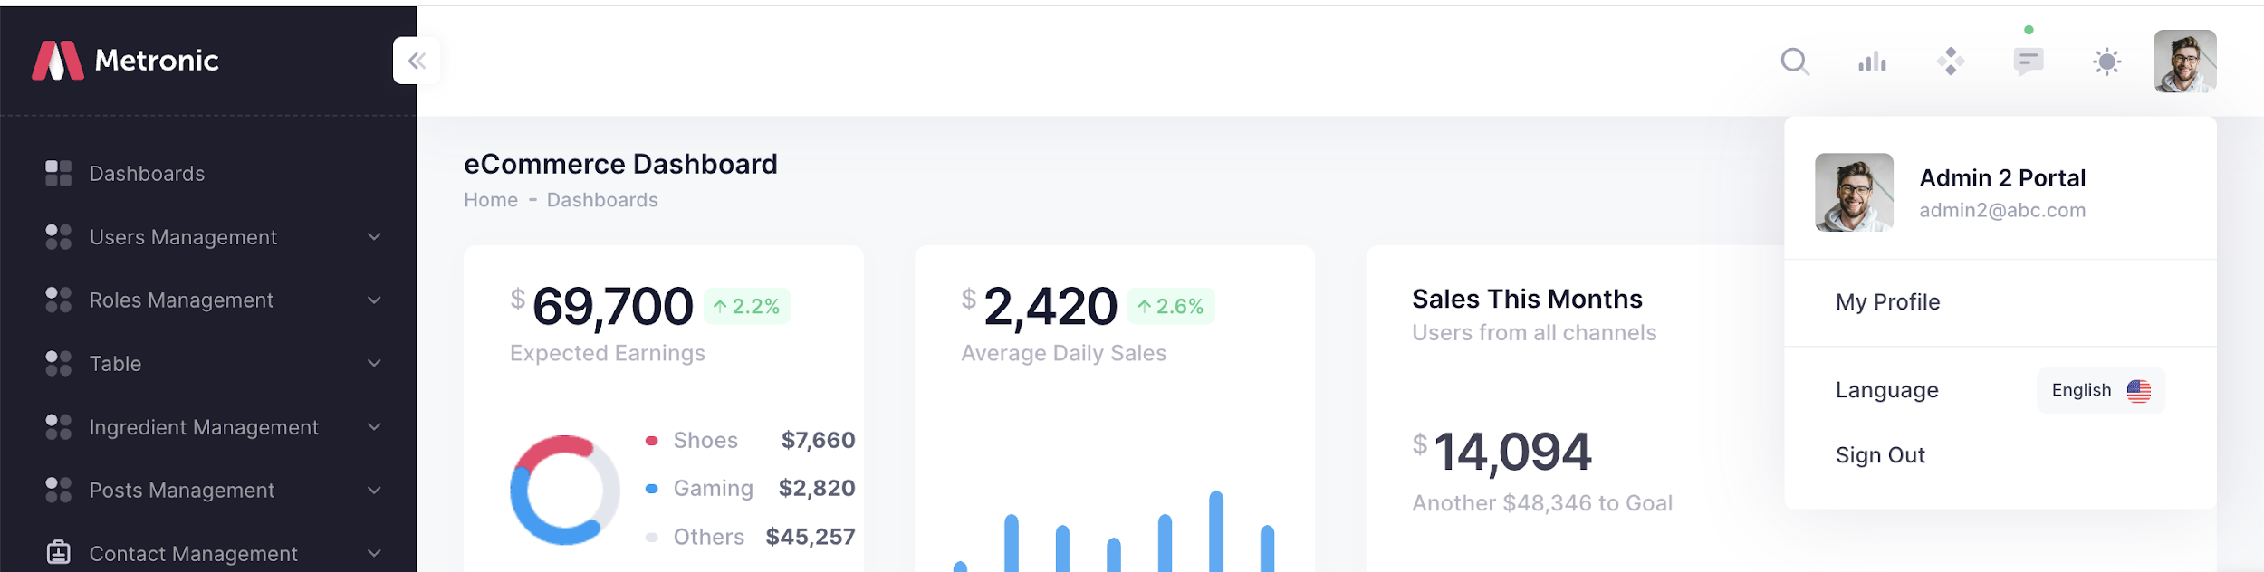

|  |  |  |
| --- | --- | --- |
| **N.o** | **Name** | **Action** |
| 1. | Sidebar | Always on the left side of the admin site. Show accordion links to other pages |
| 2. | Account Pic | Show options on click |
| 3. | Profile button | Redirect to personal profile |
| 4. | Logout button | Logout and redirect to admin login page |

### Create Admin

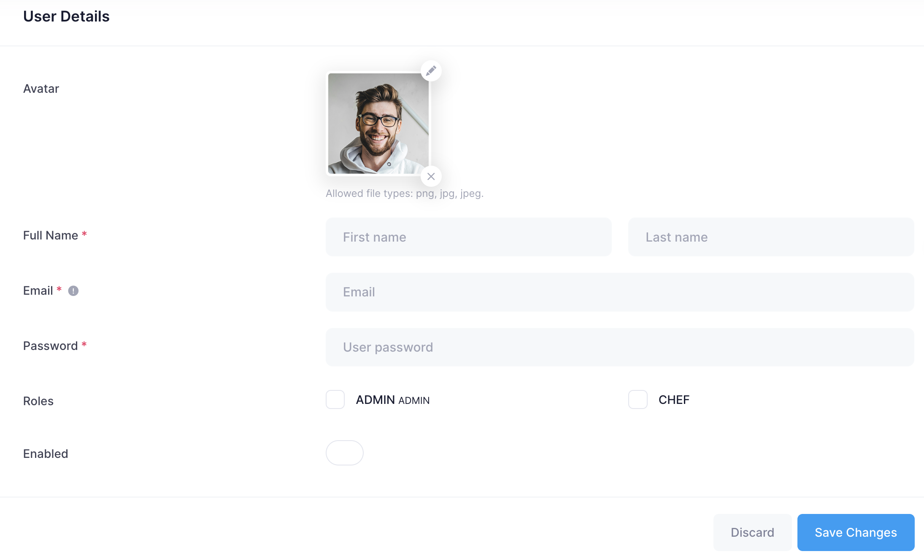

|  |  |  |
| --- | --- | --- |
| **N.o** | **Name** | **Action** |
| 1. | Admin form | Main Admin can enter admin details |
| 2. | Create button | Create an admin, automatically assign ADMIN role and redirect to details of the newly created admin |

### User List

|  |  |  |
| --- | --- | --- |
| **N.o** | **Name** | **Action** |
| 1. | List | Show list of users, their details |
| 2. | Details button | Go to user’s details |
| 3. | Profile button | If it’s the current logged-in user’s account |

### Edit Personal Details

|  |  |  |
| --- | --- | --- |
| **N.o** | **Name** | **Action** |
| 1. | Admin form | Admin can edit personal details |
| 2. | Save button | Update details after save |
| 3. | Manage profile pic | Upload new profile pic, remove current |
| 4. | Change password form | Enter current password, new password, and confirm the new password, press change to change. Password must have at least 8 character, 1 lowercase, 1 uppercase and 1 digit |

### User/Details Details

|  |  |  |
| --- | --- | --- |
| **N.o** | **Name** | **Action** |
| 1. | Details | Show details of user/admin |
| 2. | Remove Pic button | Delete the profile picture of this user/admiin |
| 3. | Role Select | Change the role for the account Admin can only change Admin and bellow  Banned users will not be able to log in or get data |
| 4. | Delete account button | Delete the account |

### **Post Management**

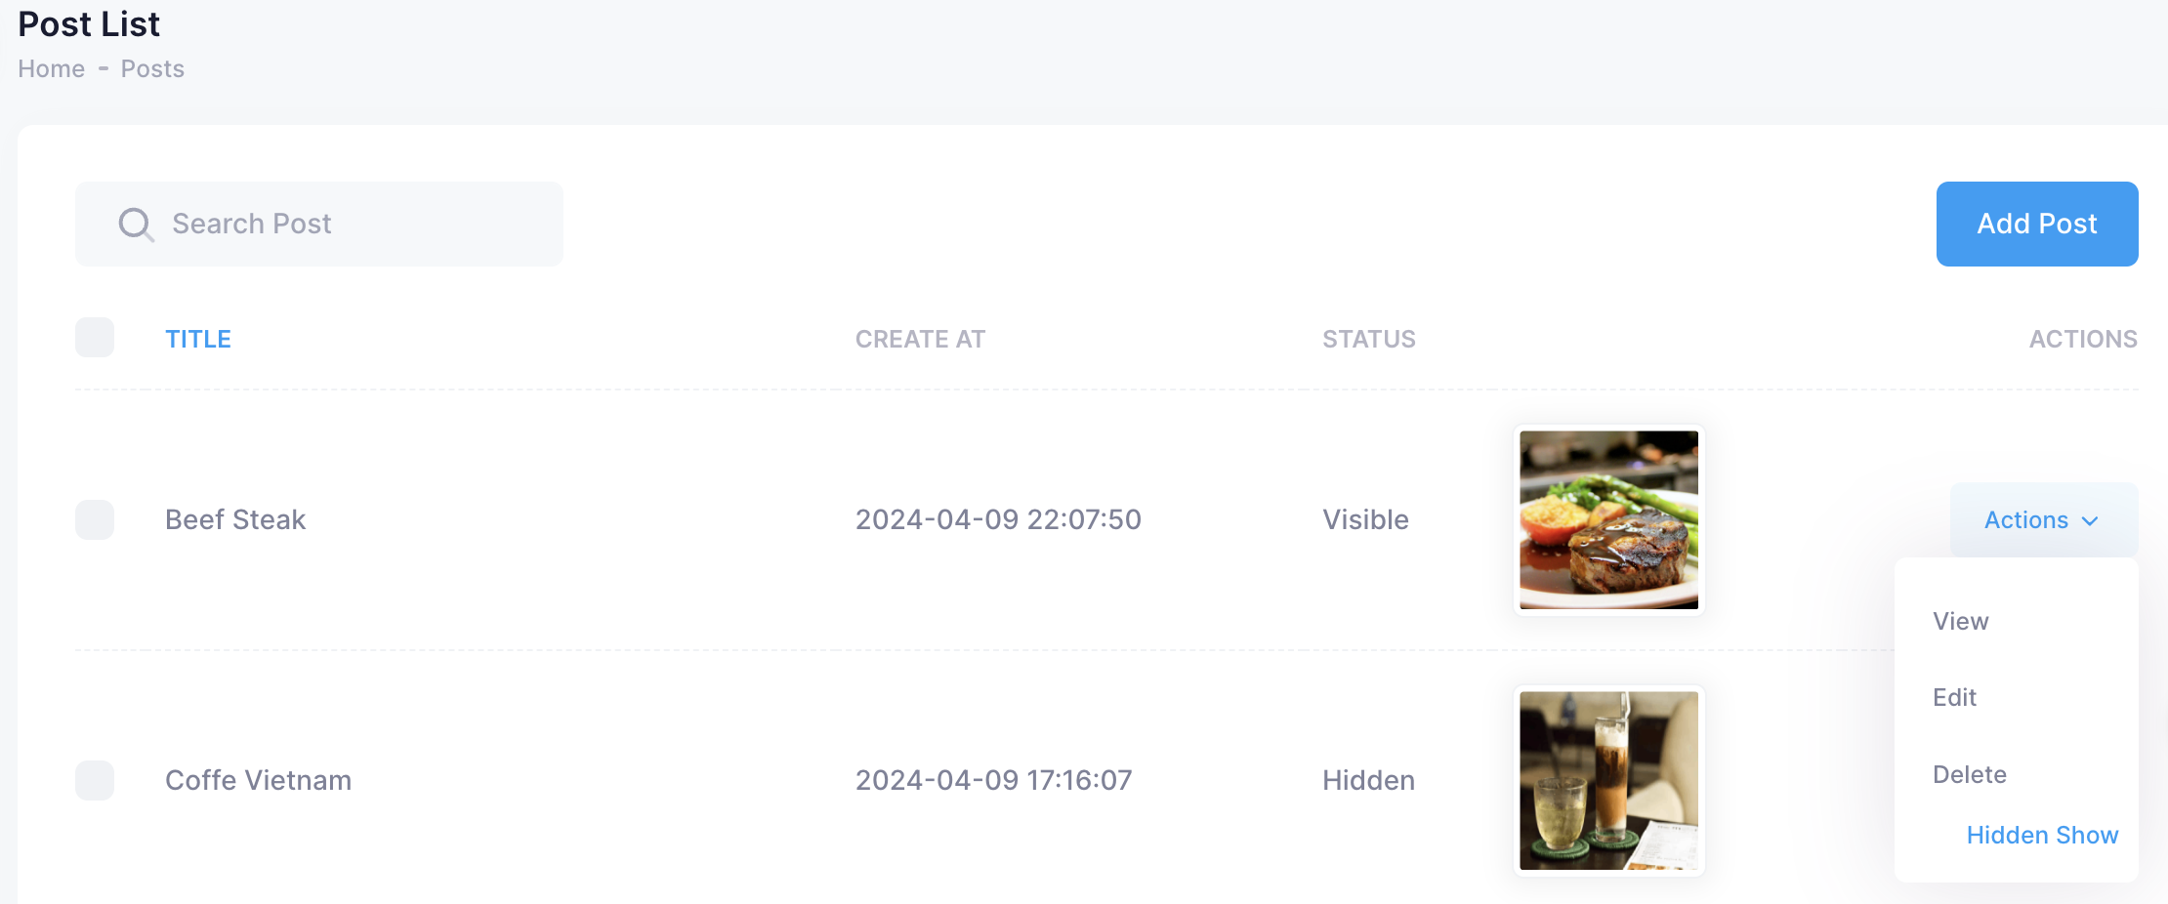

|  |  |  |
| --- | --- | --- |
| **N.o** | **Name** | **Action** |
| 1. | Title | Show the name of post |
| 2. | Search Post | Search the name of post |
| 3. | Add Post | Add the new post |
| 4. | Delete post button | Delete the post |
| 5 | Edit post button | Edit the post |
| 6 | Hidden /Show | Hide/Show the post on user performance |

### **Post Edit Management**

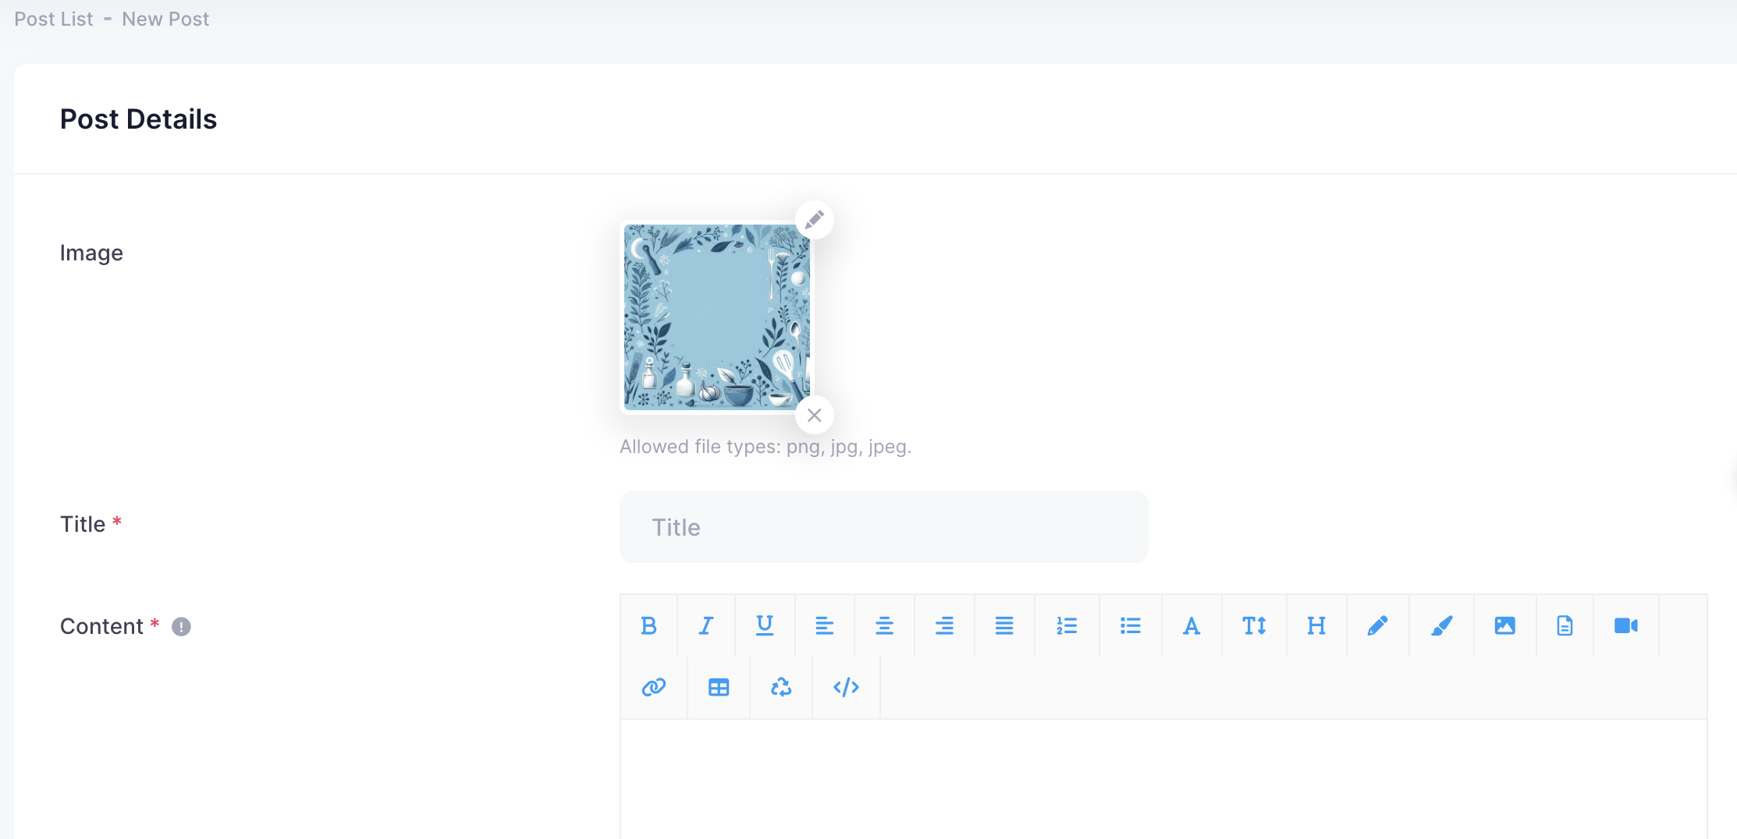

|  |  |  |
| --- | --- | --- |
| **N.o** | **Name** | **Action** |
| 1 | Add Image | Upload Image for a post |
| 2 | Add title | Add title for a post |
| 3 | Content | Upload the content (html) for a post |

### **Contact Management**

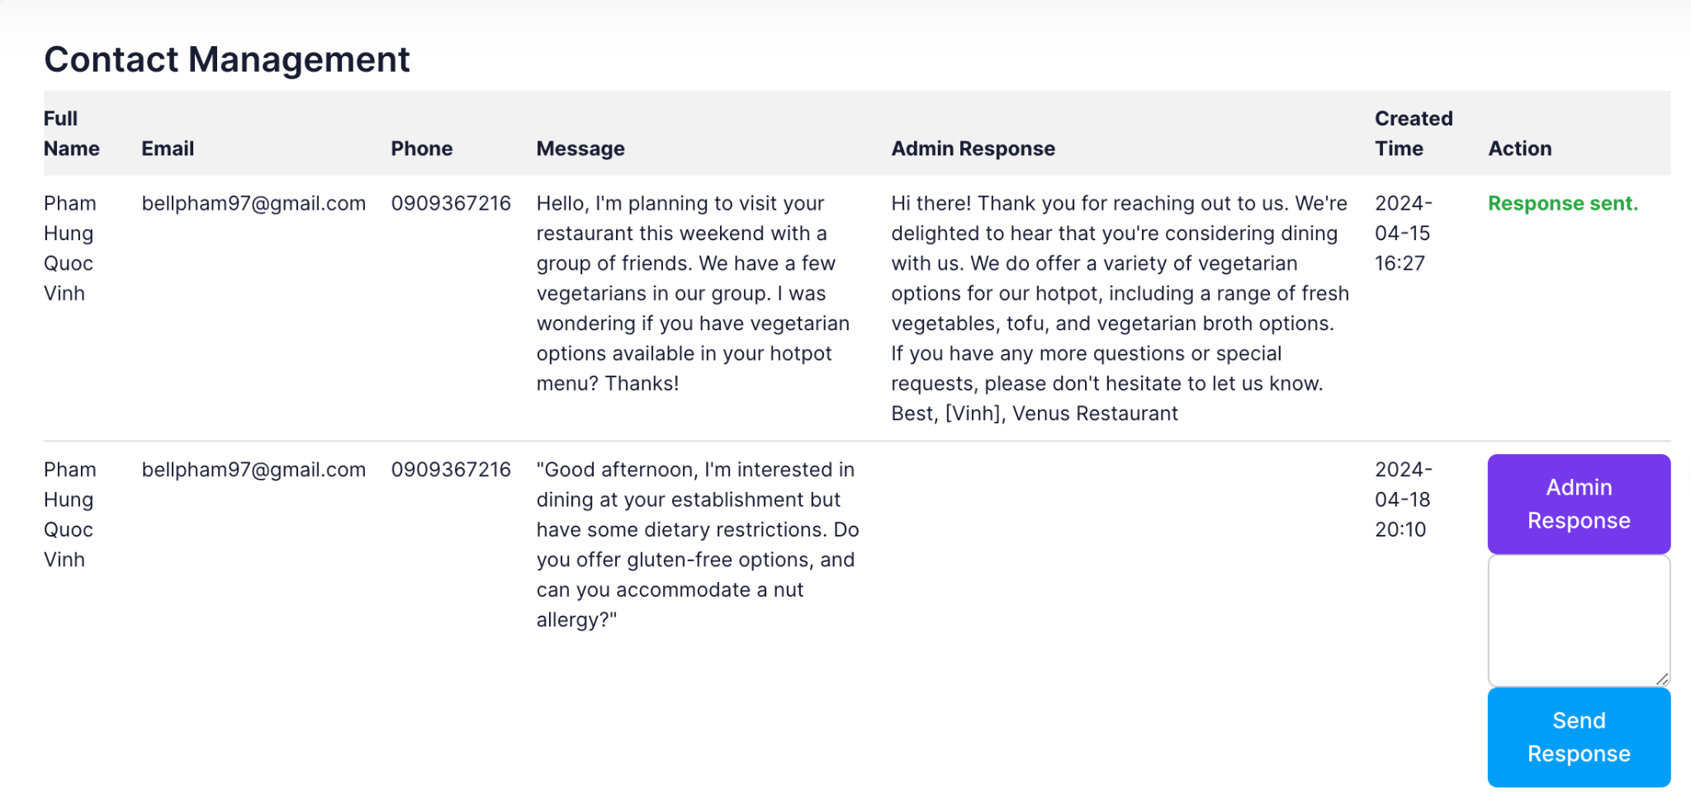

|  |  |  |  |  |
| --- | --- | --- | --- | --- |
| **No.** | **Name** | **Type** | **Event** | **Description** |
| 1 | Response | button | Click | Click to reply customer’s message |

* 1. **Chef Management**

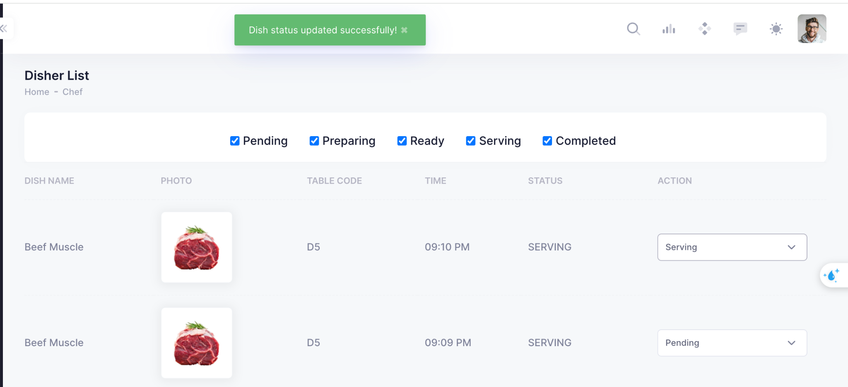

|  |  |  |  |  |
| --- | --- | --- | --- | --- |
| **No.** | **Name** | **Type** | **Event** | **Description** |
| 1 | Action | button | Click | Chef can change the status of ordered dishes |
| 2 | Filter | button | Click | Chef can sort the status of ordered dishes |

### **1.11 Reservation Management**

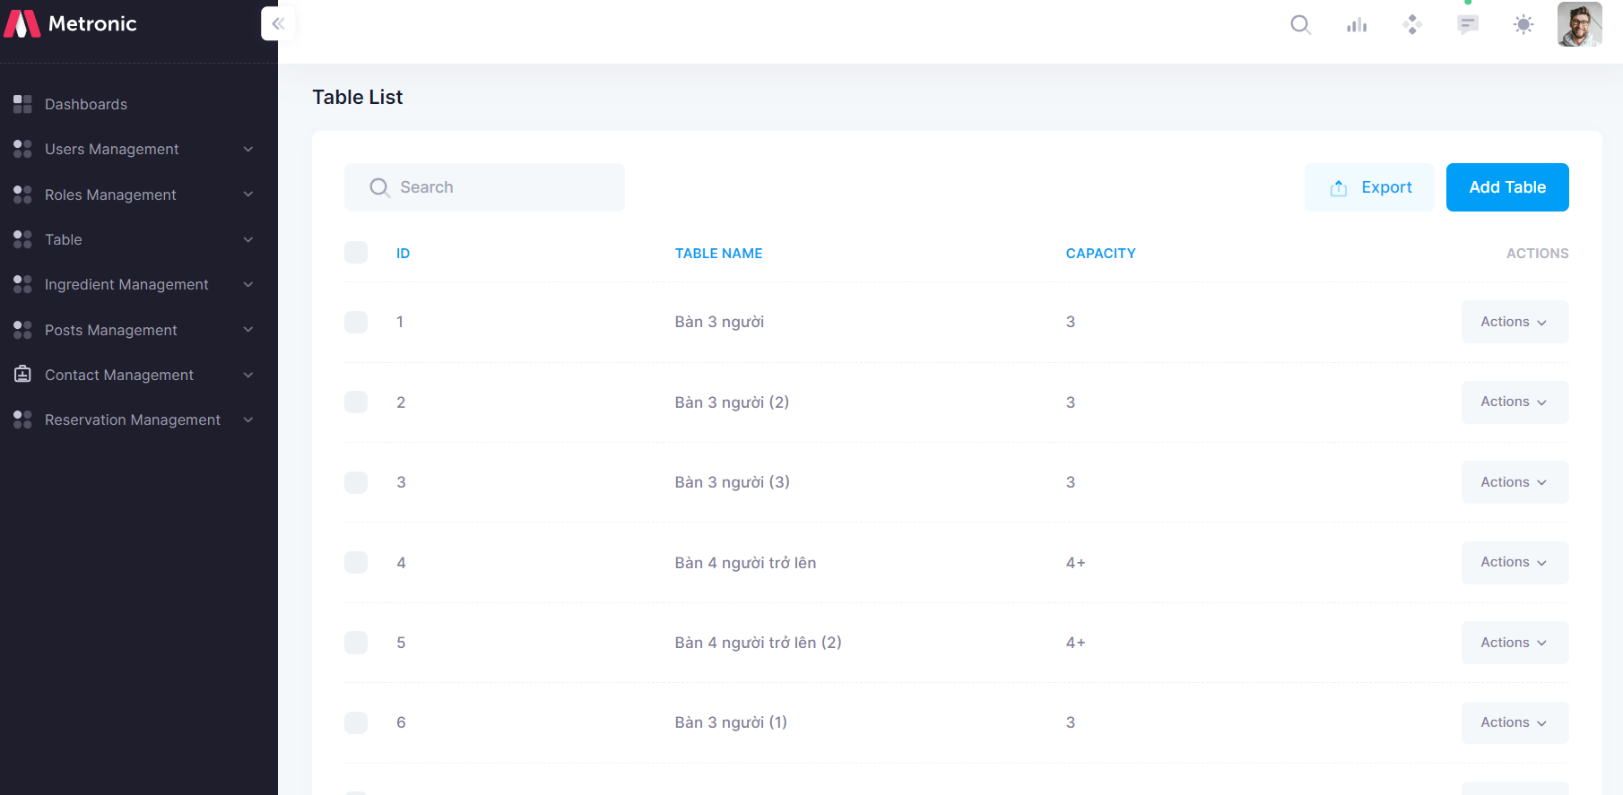

|  |  |  |  |  |
| --- | --- | --- | --- | --- |
| **No.** | **Name** | **Type** | **Event** | **Description** |
| 1 | Add Table | button | Click | Create a dining table information form |

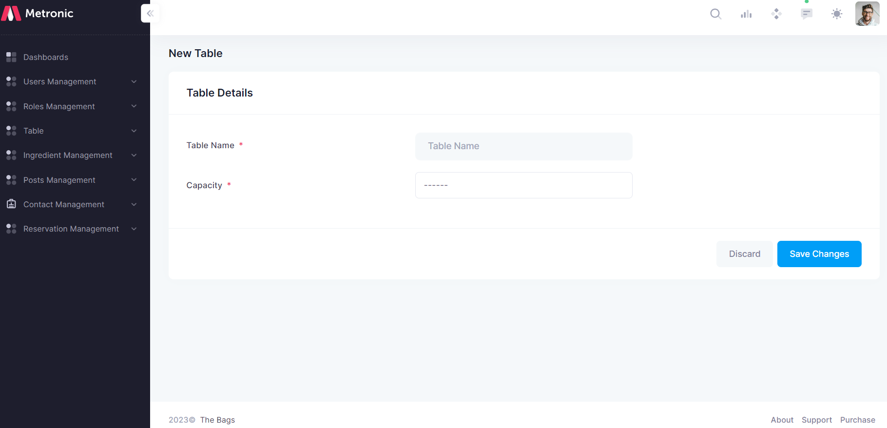

|  |  |  |  |  |
| --- | --- | --- | --- | --- |
| **No.** | **Name** | **Type** | **Event** | **Description** |
| 1 | Save | button | Click | save information |

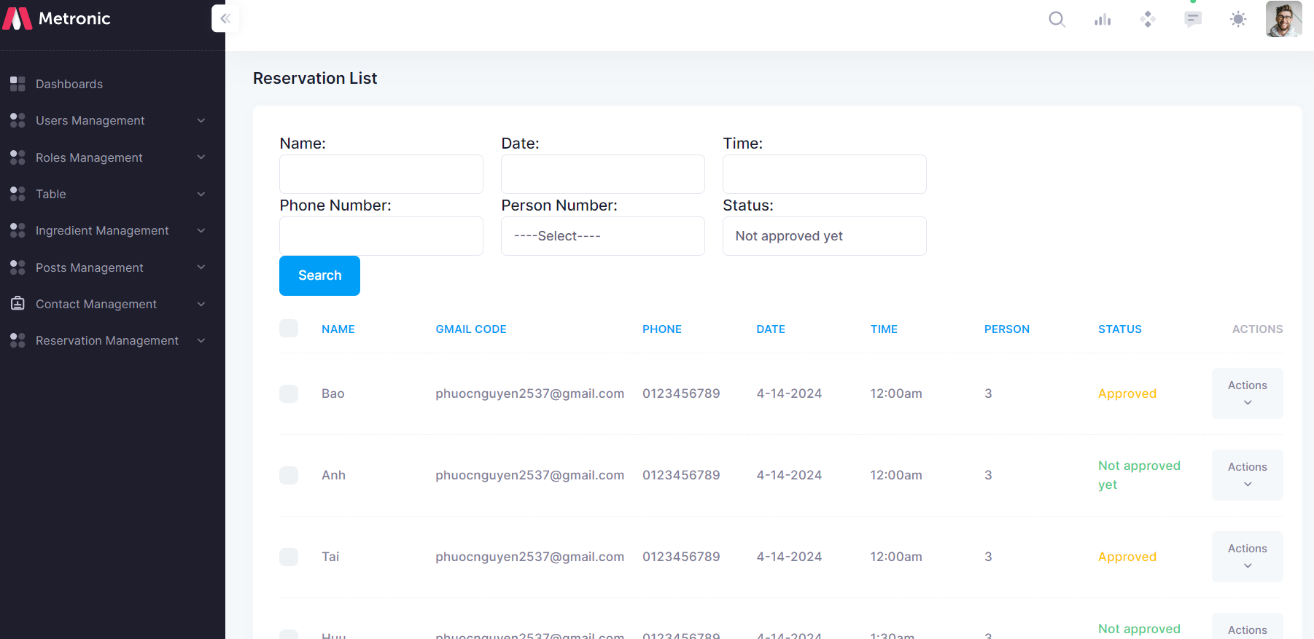

|  |  |  |  |  |
| --- | --- | --- | --- | --- |
| **No.** | **Name** | **Type** | **Event** | **Description** |
| 1 | Search | button | Click | Find order information |
| 2 | Approve | button | Click | Approve the table order |

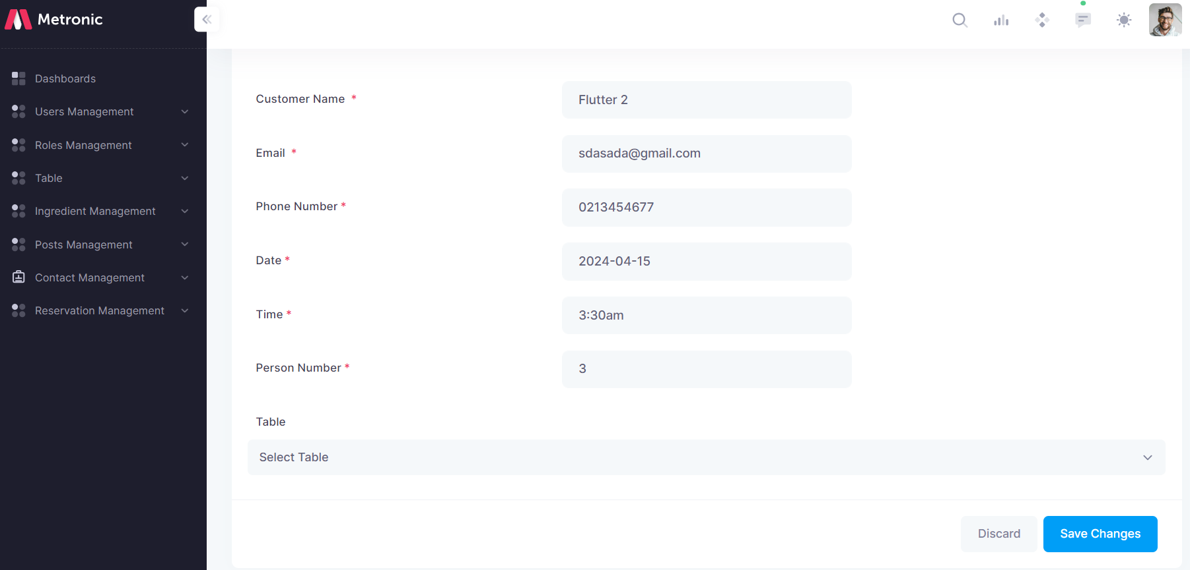

| **No.** | **Name** | **Type** | **Event** | **Description** |
| --- | --- | --- | --- | --- |
| 1 | Save | button | Click | Save approval information and send email |

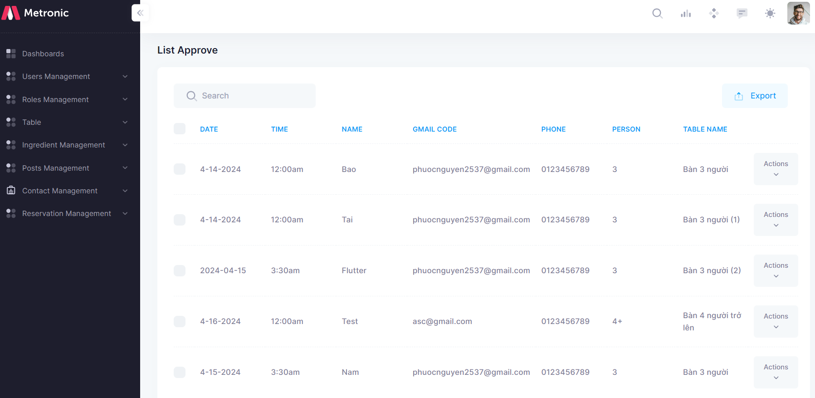

### **1.12 Table Management**

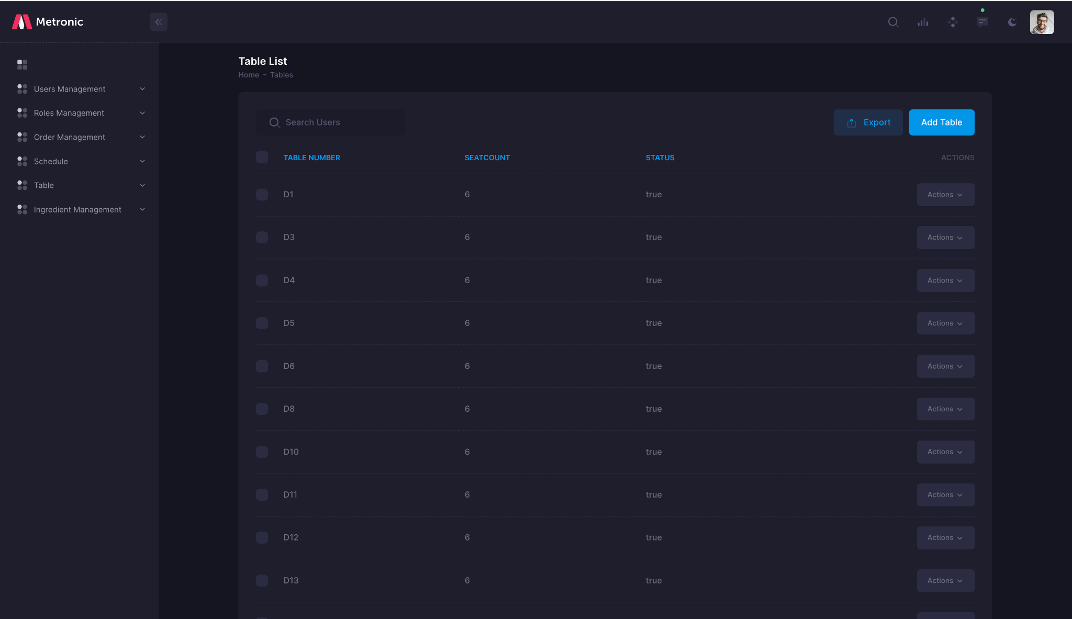

| **No.** | **Name** | **Type** | **Event** | **Description** |
| --- | --- | --- | --- | --- |
| **1** | **search** | **button** | **click** | **Sear table , category** |
| 2 | Submit | button | Click | Save Category of table |

### **1.13 Disher Management**

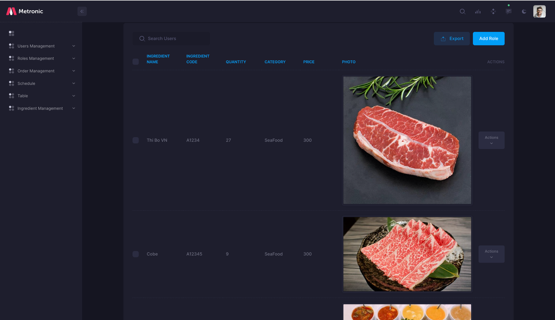

| **No.** | **Name** | **Type** | **Event** | **Description** |
| --- | --- | --- | --- | --- |
| **1** | **search** | **button** | **click** | **Sear Disher** |
| 2 | Submit | button | Click | Save Disher |

### **1.13 Staff Management**

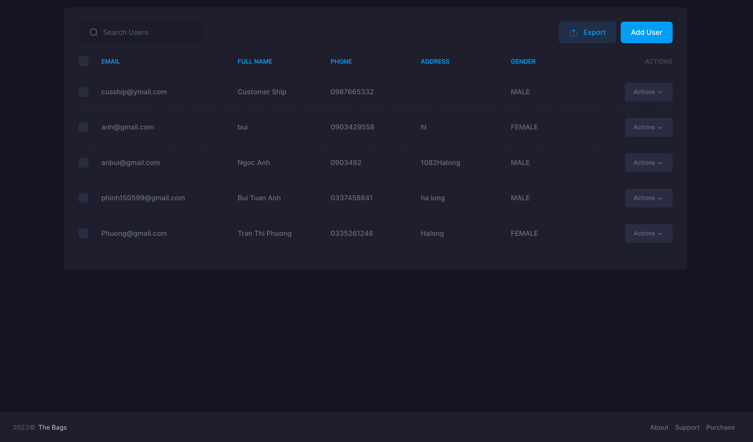

| **No.** | **Name** | **Type** | **Event** | **Description** |
| --- | --- | --- | --- | --- |
| **1** | **search** | **button** | **click** | **Sear Staff** |
| 2 | Submit | button | Click | Save Staff |

1.15 .**Ingredient Management**

| **No.** | **Action** | **Type** | **Event** | **Description** |
| --- | --- | --- | --- | --- |
| **1** | **Add Category** | **button** | **click** | **Add New Category** |
| 2 | Search | button | type | Search Category name |

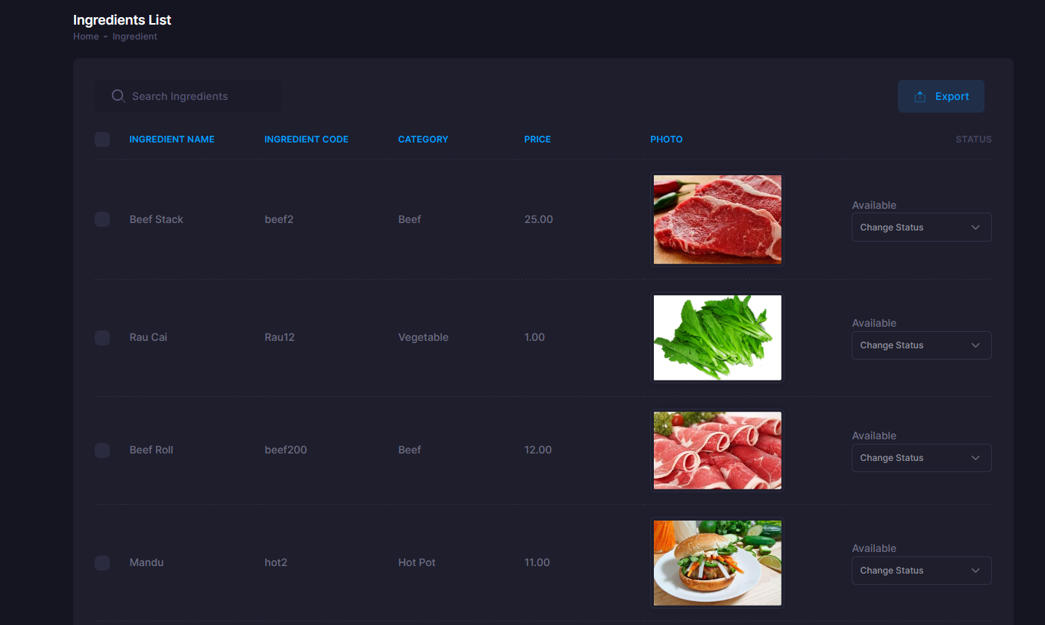

| **No.** | **Action** | **Type** | **Event** | **Description** |
| --- | --- | --- | --- | --- |
| 1 | Search | button | type | Search Ingredient name |
| 2 | Update status | Drop down | choose | Update status Available will show in FrontEnd,Expired/OutofStock will hide it |
| 3 | Export | button | Click | Export List of Ingredient |
| 4 | Edit Ingredient | button | Click | Update Ingredient Information |

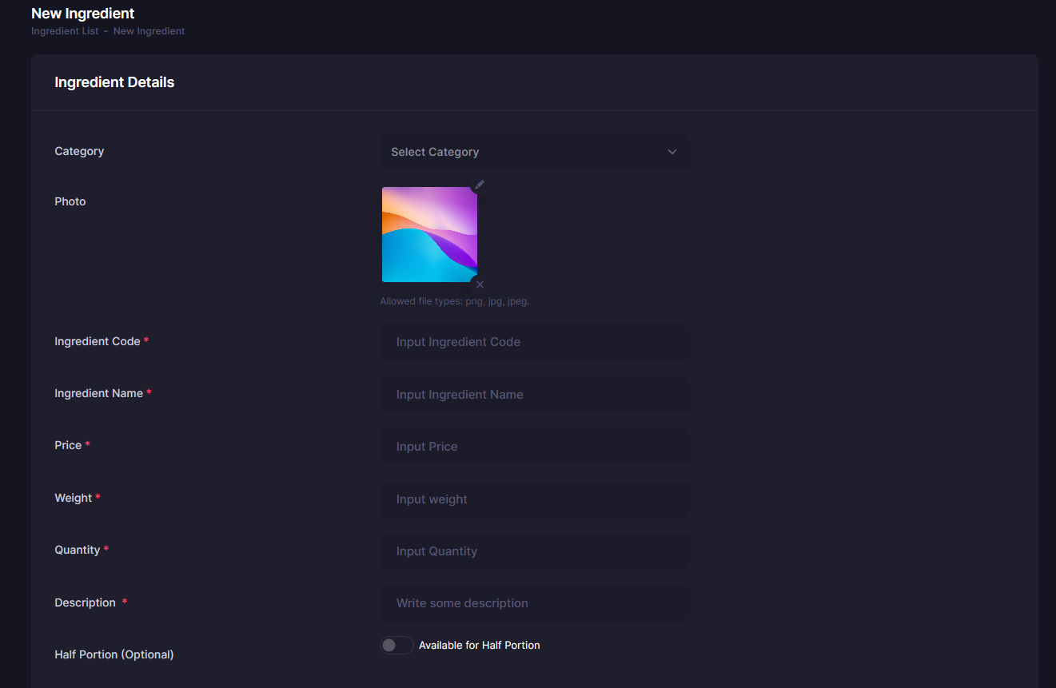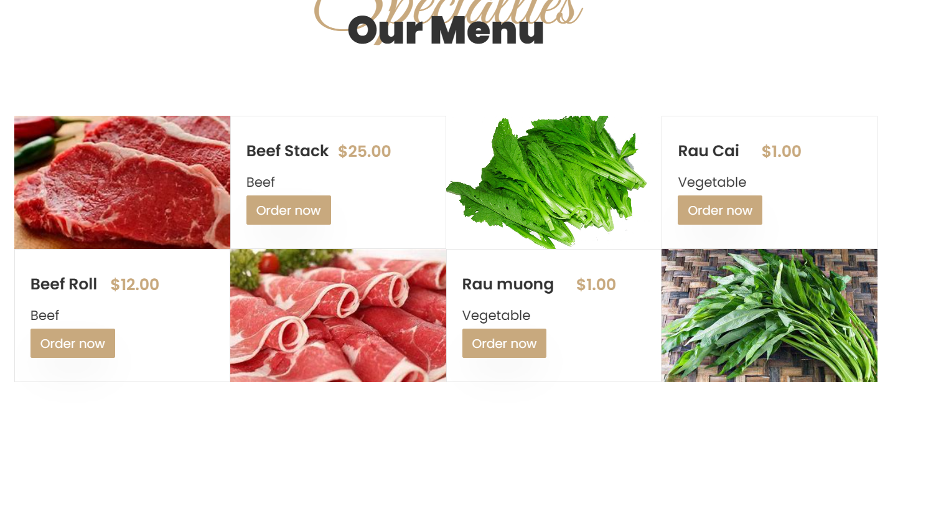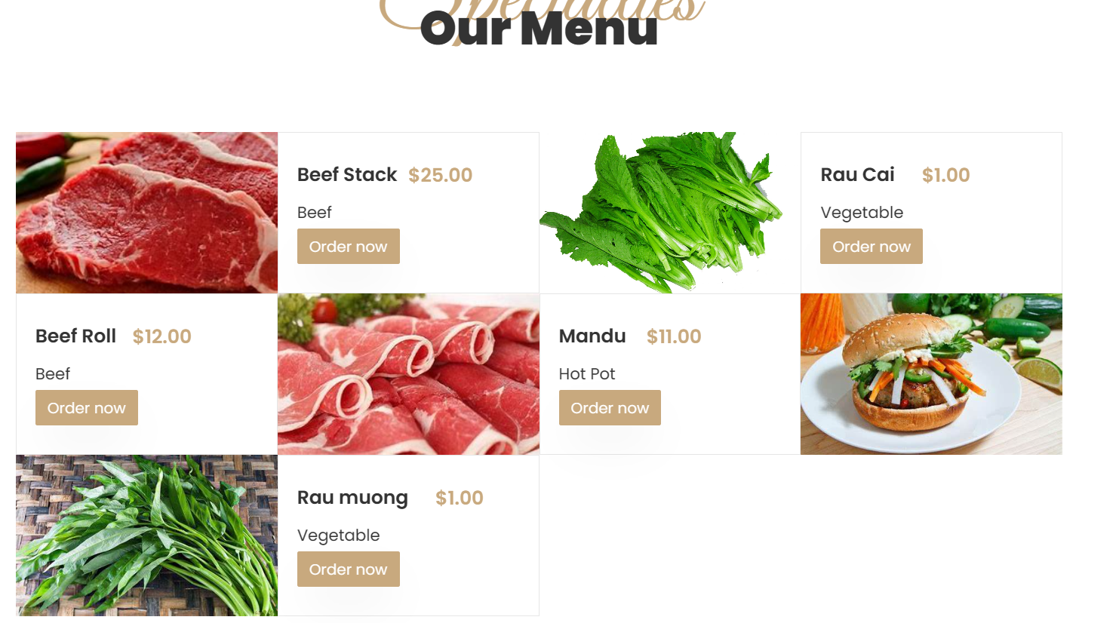

| **No.** | **Action** | **Type** | **Event** | **Description** |
| --- | --- | --- | --- | --- |
| 1 | Add Ingredient | button | click | Add New Ingredient |

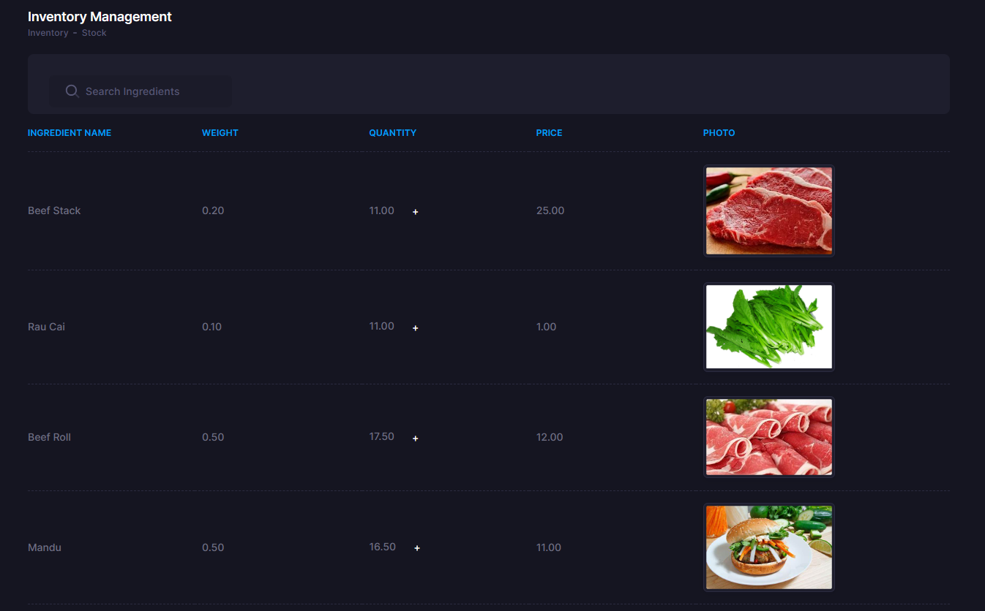

| **No.** | **Action** | **Type** | **Event** | **Description** |
| --- | --- | --- | --- | --- |
| 1 | Update quantity | button | click | Update quantity |
|  |  |  |  |  |

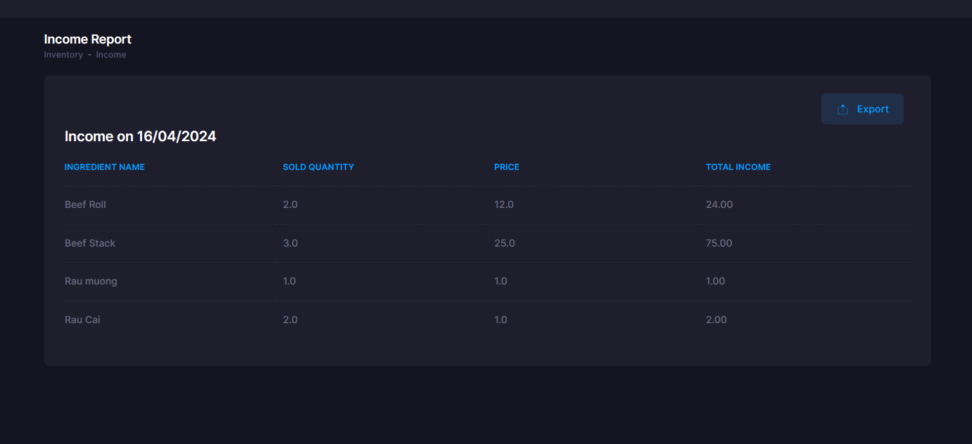

| **No.** | **Action** | **Type** | **Event** | **Description** |
| --- | --- | --- | --- | --- |
| 1 | Get All Income | query | - | Get All Income in a Day |
| 2 | Export | button | click | Export excel file of income on day |

## **User:**

### Login

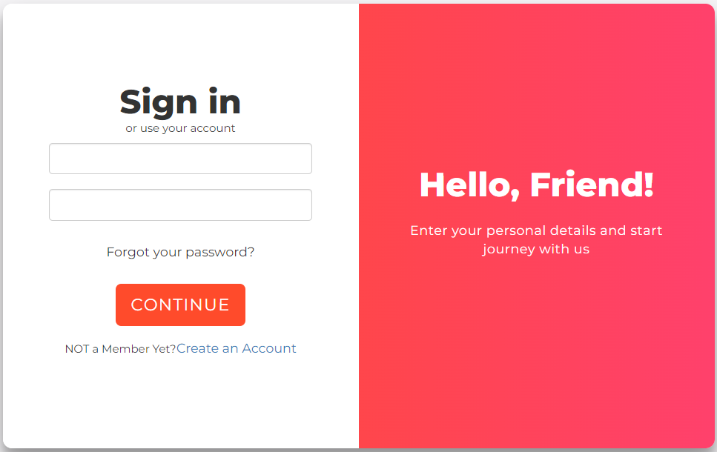

|  |  |  |
| --- | --- | --- |
| **N.o** | **Name** | **Action** |
| 1. | Login form | User input email and password |
| 2 | Login button | Redirect to Team List (Team Create if user have no team) if email and password are valid and available in database |
| 3 | Sign up button | Switch form to sign up form |

### **Create Account**

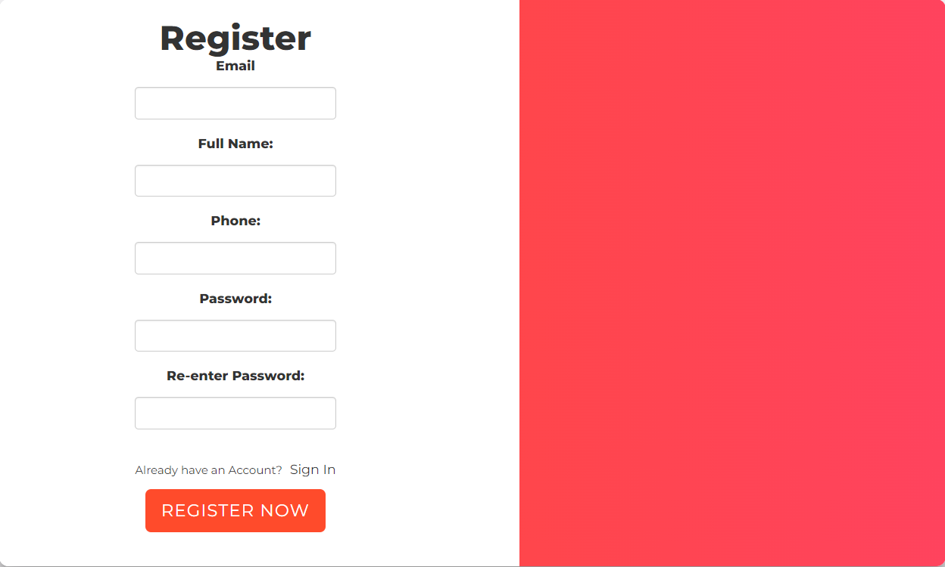

|  |  |  |
| --- | --- | --- |
| **N.o** | **Name** | **Action** |
| 1. | Sign in form | User input details (fullname, email, and password are required). User can also upload a profile picture |
| 2 | Sign up button | Switch to Login form once sign up is successful |
| 3 | Login button | Switch form to Login form |

### Profile

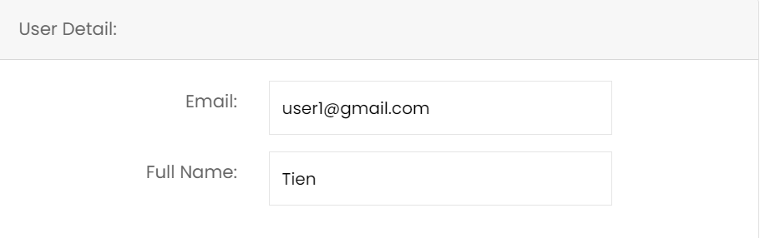

|  |  |  |
| --- | --- | --- |
| **N.o** | **Name** | **Action** |
| 1. | Manage profile pic | User can upload their own profile pic or remove the current |
| 2 | Profile details | Show details of account. Press **SAVE CHANGE** button to save the changes |
| 3 saw | Change password form | Enter current password, new password, and confirm the password. Press **CHANGE PASSWORD** to change the password. Password needs to have at least 8 characters, 1 lowercase, 1 uppercase, and 1 digit |

* 1. **Post Page**

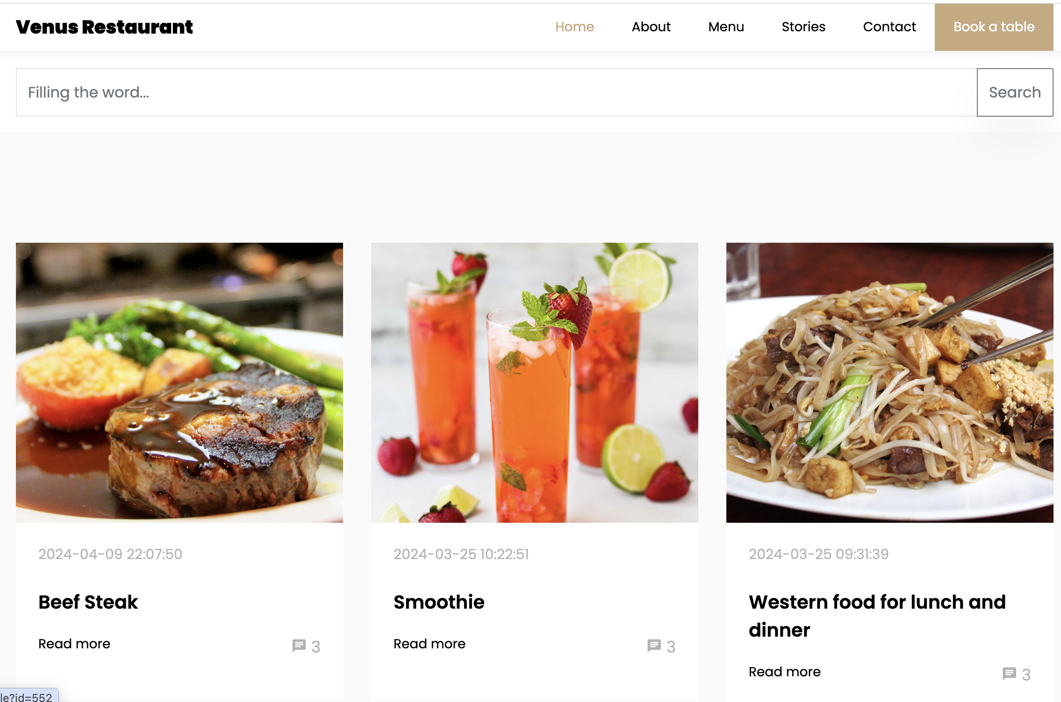

|  |  |  |  |  |
| --- | --- | --- | --- | --- |
| **No.** | **Name** | **Type** | **Event** | **Description** |
| 1 | Filling the word (Search) | button | Click | Users can search any keywords |
| 2 | Read more | button | Click | User can read in details of a post |

* 1. **Contact Page**
* 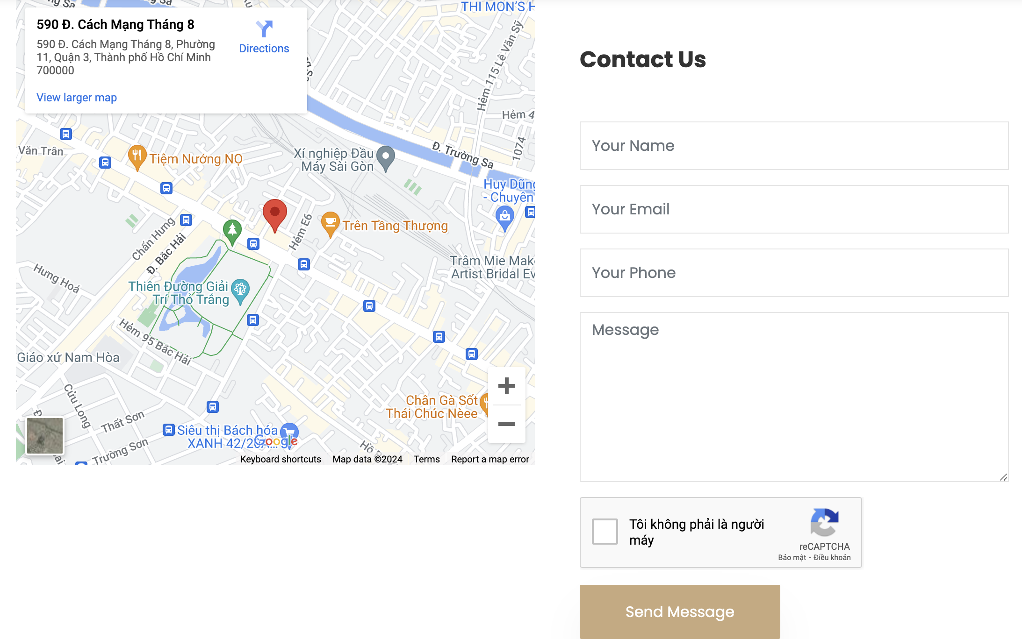

|  |  |  |  |  |  |
| --- | --- | --- | --- | --- | --- |
| **No.** | **Name** | **Validate** | **Type** | **Event** | **Description** |
| 1 | Your name | Required | Textbox | On Type | Input Client name |
| 2 | Your Email Address | Required | Textbox | On Type | Input Client email |
| 3 | Your phone number | Required | Textbox | On Type | Input Client phone |
| 4 | Message | Required | Textbox | On Type | Input Client’s message |
| 6 | RCapcha | Required | Button | click | To verify sender |
| 6 | Submit | Required | Button | click | Sent messages to Admin/database |

* 1. **Index Page**

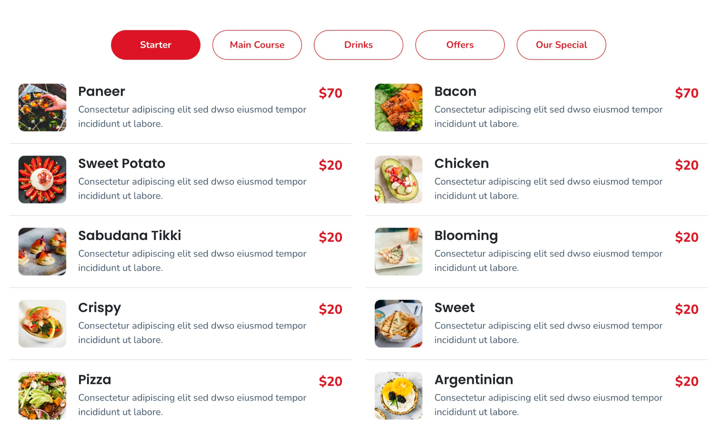

|  |  |  |  |  |
| --- | --- | --- | --- | --- |
| **No.** | **Name** | **Type** | **Event** | **Description** |
| 1 | Filling the word (Search/Filter) | button | Click | Users can search any keywords |

* 1. **About Page**

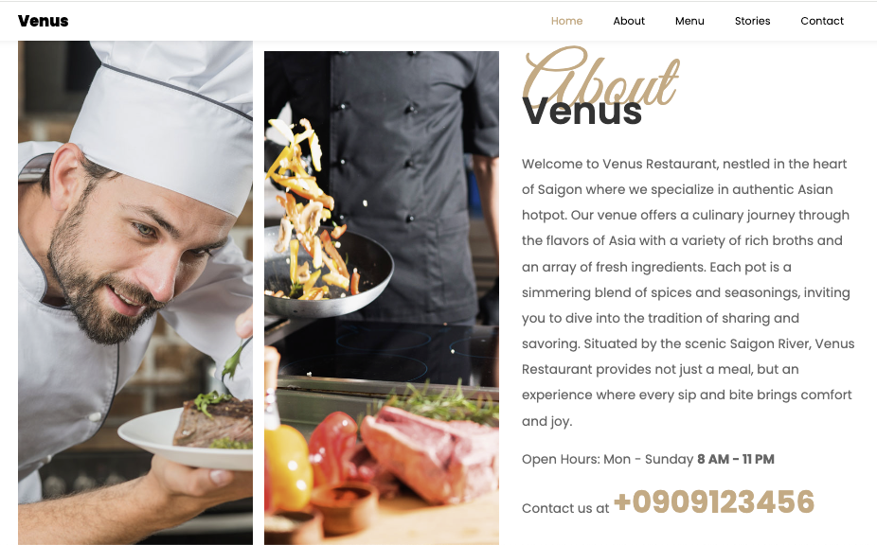

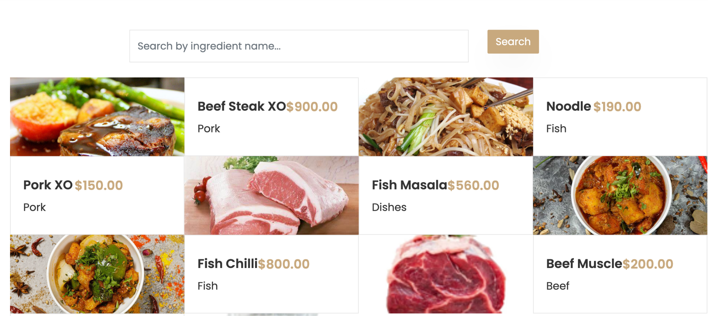

|  |  |  |  |  |
| --- | --- | --- | --- | --- |
| **No.** | **Name** | **Type** | **Event** | **Description** |
| 1 | Filling the word (Search/Filter) | button | Click | Users can search any keywords |

**2.8 Booking Table**

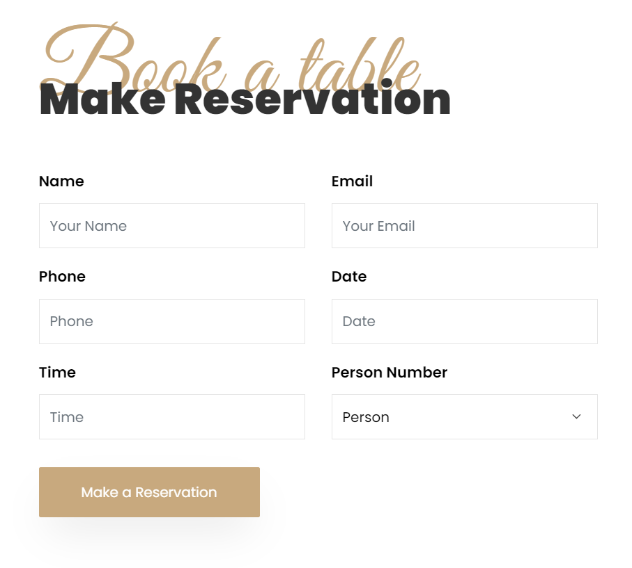

| **No.** | **Name** | **Validate** | **Type** | **Event** | **Description** |
| --- | --- | --- | --- | --- | --- |
| 1 | Your name | Required | Textbox | On Type | Input Client name |
| 2 | Your Email Address | Required | Textbox | On Type | Input Client email |
| 3 | Your phone number | Required | Textbox | On Type | Input Client phone |
| 4 | Date | Required | Textbox | On Type | Input Client’s date |
| 6 | Time | Required | Option | Click | Select Client’s time |
| 7 | Person Number | Required | Option | Click | Select person number |
| 8 | Submit | Required | Button | click | Sent messages to Admin/database |

# 2.7 List and table status

|  |  |  |  |
| --- | --- | --- | --- |
| **No.** | **Name** | **Type** | **Description** |
| 1 | Button | Button | Choose zone |

**2.8 - E-menu and Cart**

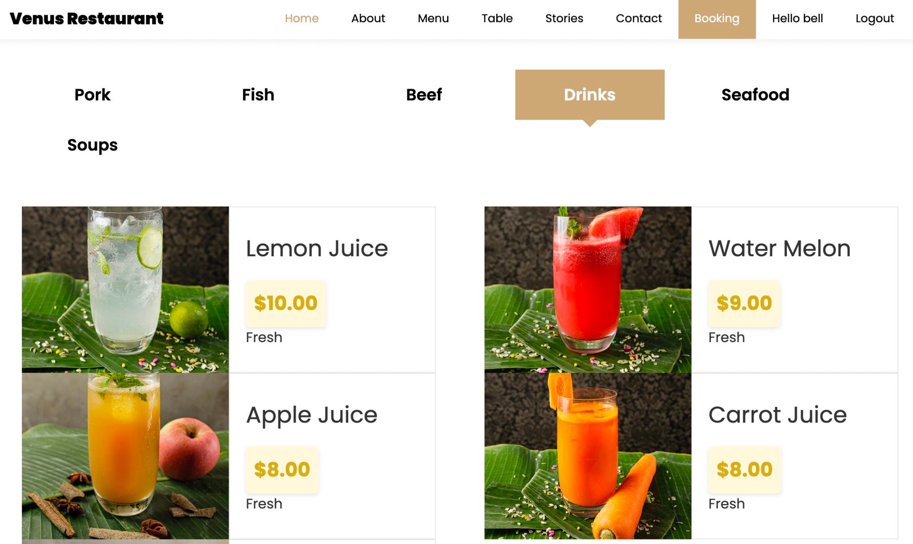

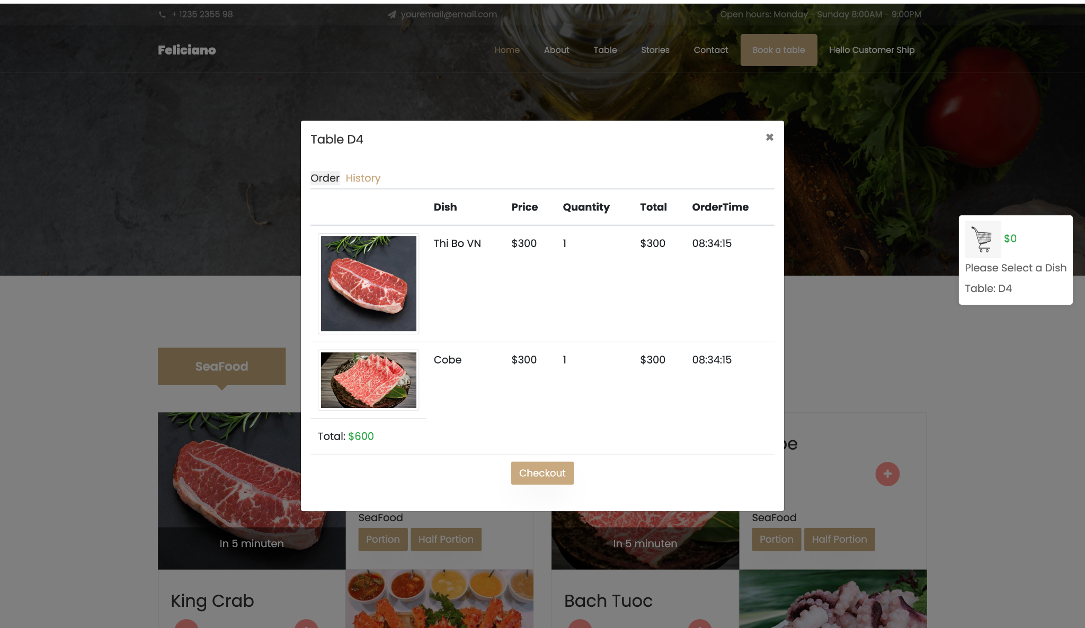

# 

|  |  |  |  |
| --- | --- | --- | --- |
| **No.** | **Name** | **Type** | **Description** |
| 1 | Button | Button | Chooe zone |
| 2 | + | Button | Add to cart |
| 3 | - | button | Minus quantity |
| 4 | Close | button | Close Cart |
| 5 | x | button | Remove to cart |
| 6 | Place Order | button | Submit Order |
| 7 | Check Out | button | Checkout |

**2.9. Check Out**

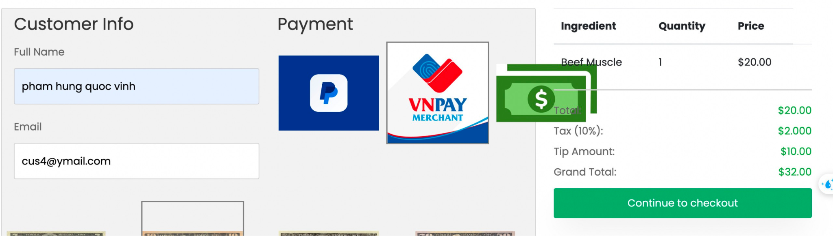

|  |  |  |  |  |
| --- | --- | --- | --- | --- |
| **No.** | **Name** | **Type** | **Event** | **Description** |
| 1 | Fullname | form | filling | Users can fill their names |
| 2 | Email | form | filling | Users can fill their emails |
| 3 | Payment | button | click | User can choose payment methods |
| 4 | Continue Checkout | button | click | It will open a payment webto continue check out and send an email success/invoice |

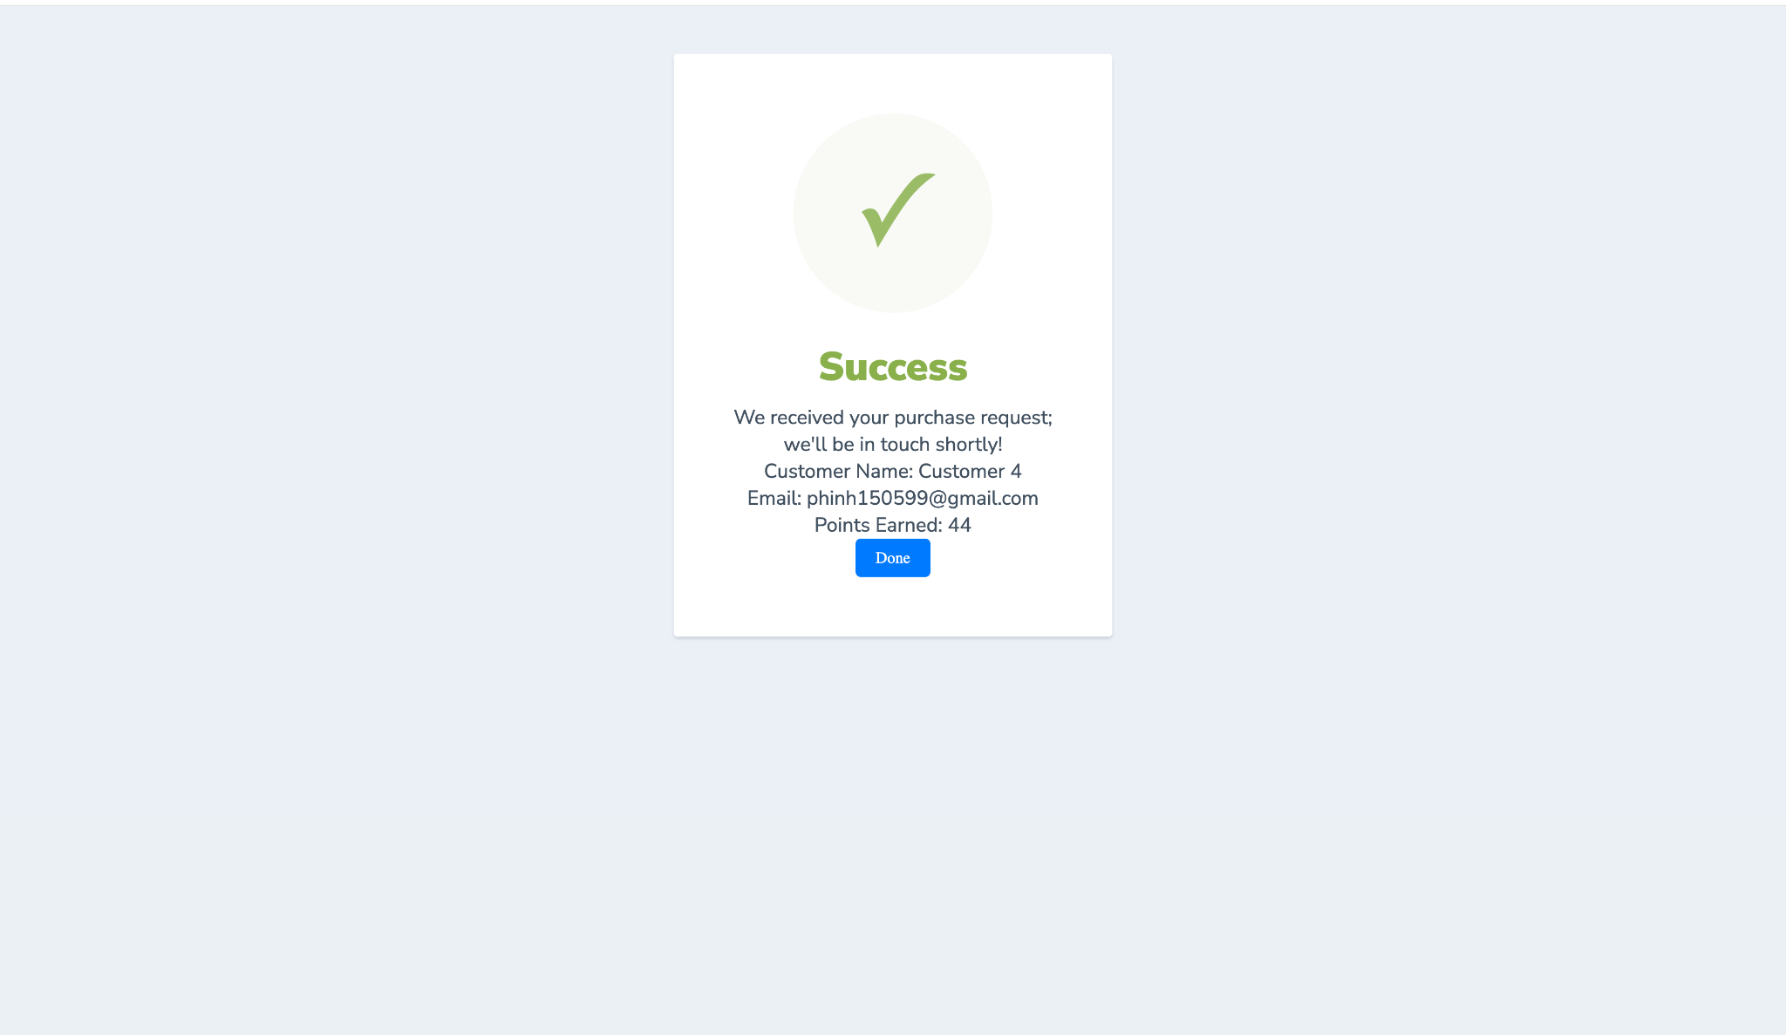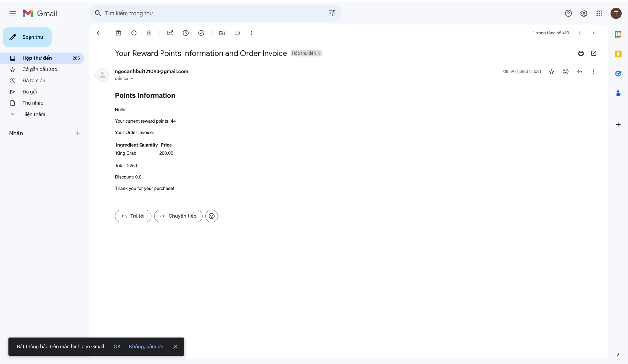

# Android:

## **User:**

### Opening Screen (Show logo)

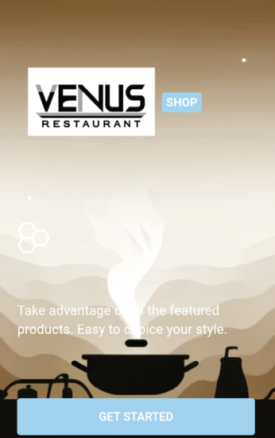

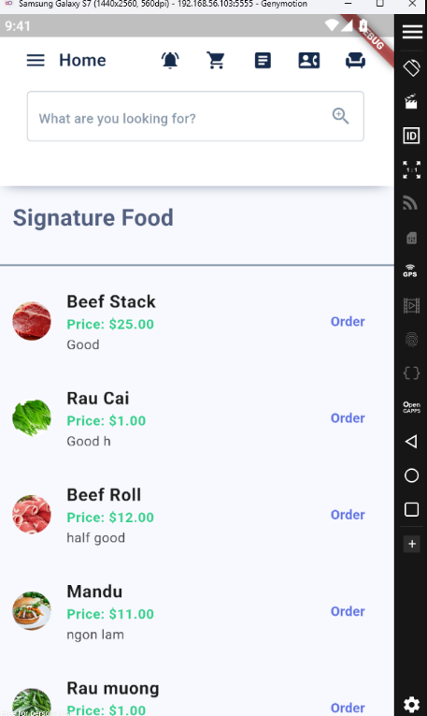

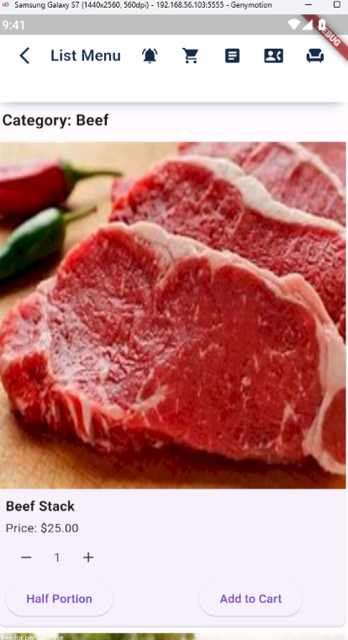

### Login

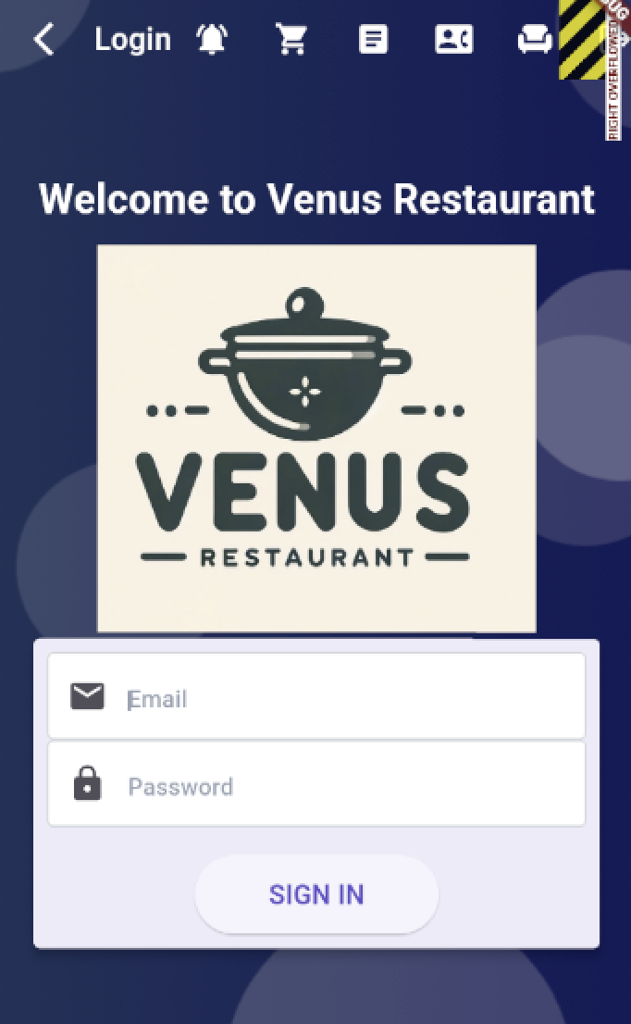

|  |  |  |
| --- | --- | --- |
| **N.o** | **Name** | **Action** |
| 1 | Login form | Enter email and password. Then press **Signin**  button to login |

* 1. **User Detail**

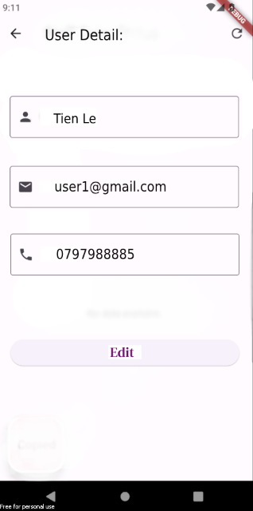

| No | Name | Action |
| --- | --- | --- |
| 1. | Manage profile pic | User can upload their own profile pic or remove the current |
| 2 | Profile details | Show details of account. Press **EDIT** button go to EDIT USER PROFILE screen |

1.4 Edit User Profile

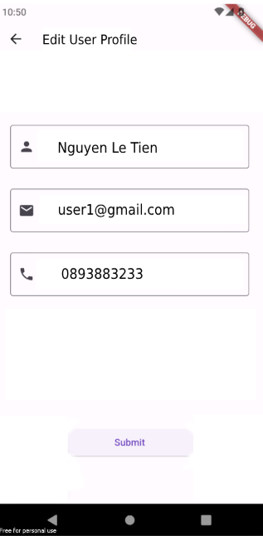

|  |  |  |
| --- | --- | --- |
| No | Name | Action |
| 1 | Display user detail | Choosing field to Edit |
| 2 | Edit detail | Press **SUBMIT** to confirm edit |

### Logout

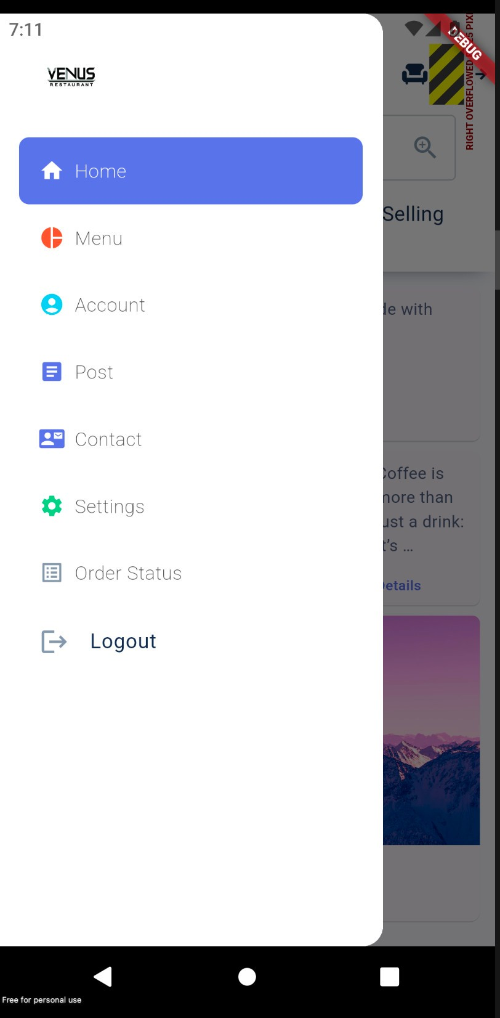

|  |  |  |
| --- | --- | --- |
| **N.o** | **Name** | **Action** |
| 1 | Logout | Logout button |

* 1. **Post Screen**

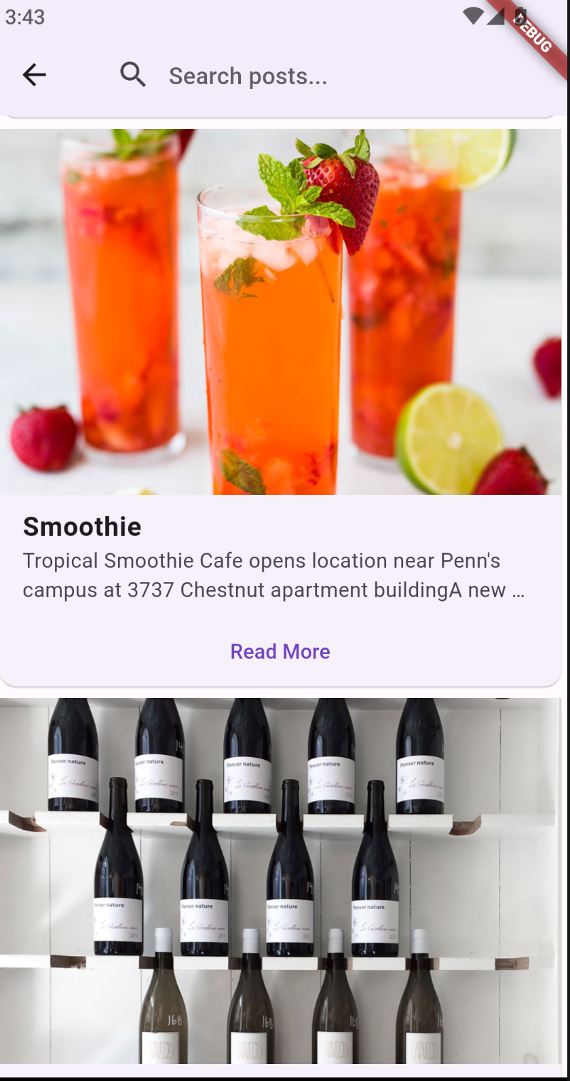

|  |  |  |
| --- | --- | --- |
| **N.o** | **Name** | **Action** |
| 1 | Search | Users can search keywords in posts |
| 2 | Read more | Users can read posts in details |

* 1. **Contact Screen**

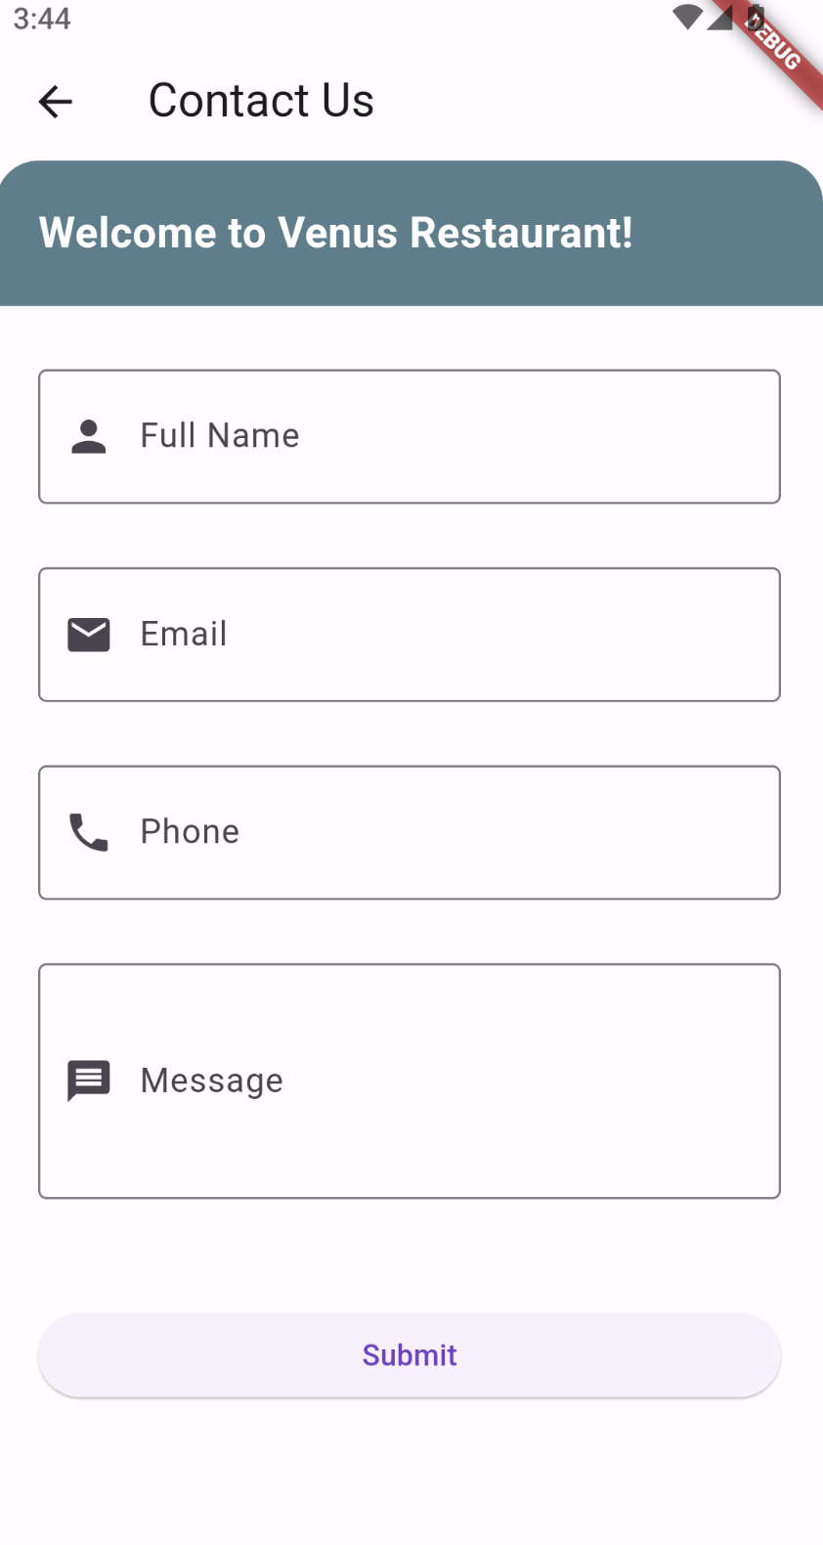

|  |  |  |  |  |  |
| --- | --- | --- | --- | --- | --- |
| **No.** | **Name** | **Validate** | **Type** | **Event** | **Description** |
| 1 | Name | Required | Textbox | On Type | Input Client name |
| 2 | Email | Required | Textbox | On Type | Input Client email |
| 3 | Your phone number | Required | Textbox | On Type | Input Client phone |
| 4 | Message | Required/ no sensitive words | Textbox | On Type | Input Client’s message |
| 5 | Submit | Required | Button | click | Sent messages to Admin/database |

* 1. **Chef Screen**

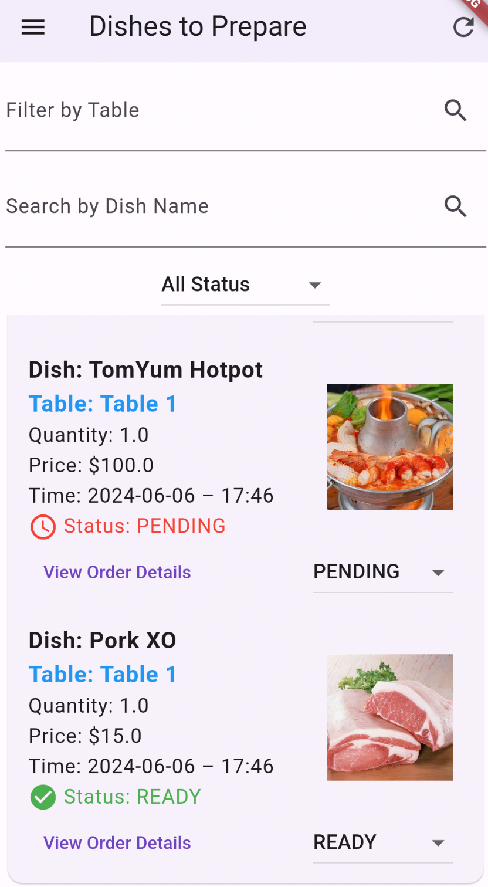

|  |  |  |
| --- | --- | --- |
| **N.o** | **Name** | **Action** |
| 1 | Filter Status | Chef can filter status of ordered dishes |
| 2 | Filter Table | Chef can filter table of ordered dishes |
| 2 | Refresh | Chef can check the newest order |
| 3 | Status | Chef can change the status of ordered dishes |

* 1. **Order Status Screen**

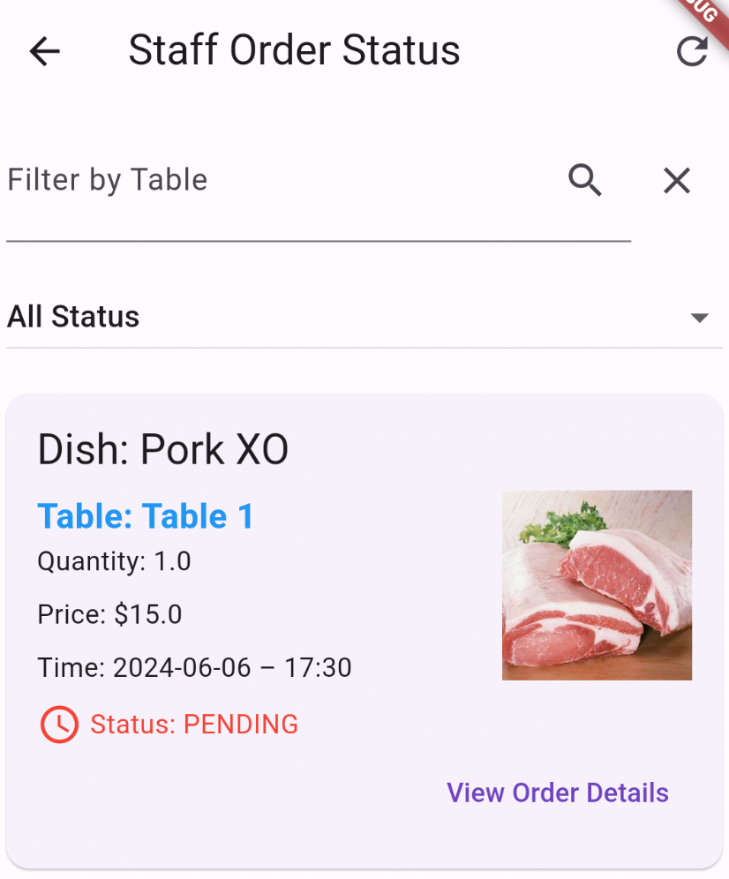

|  |  |  |
| --- | --- | --- |
| **N.o** | **Name** | **Action** |
| 1 | Filter Status | Staff can filter status of ordered dishes |
| 2 | Refresh | Staff can check the newest order |
| 3 | Filter by Table | Staff can filter orders by tables |

* 1. **Cart Screen**

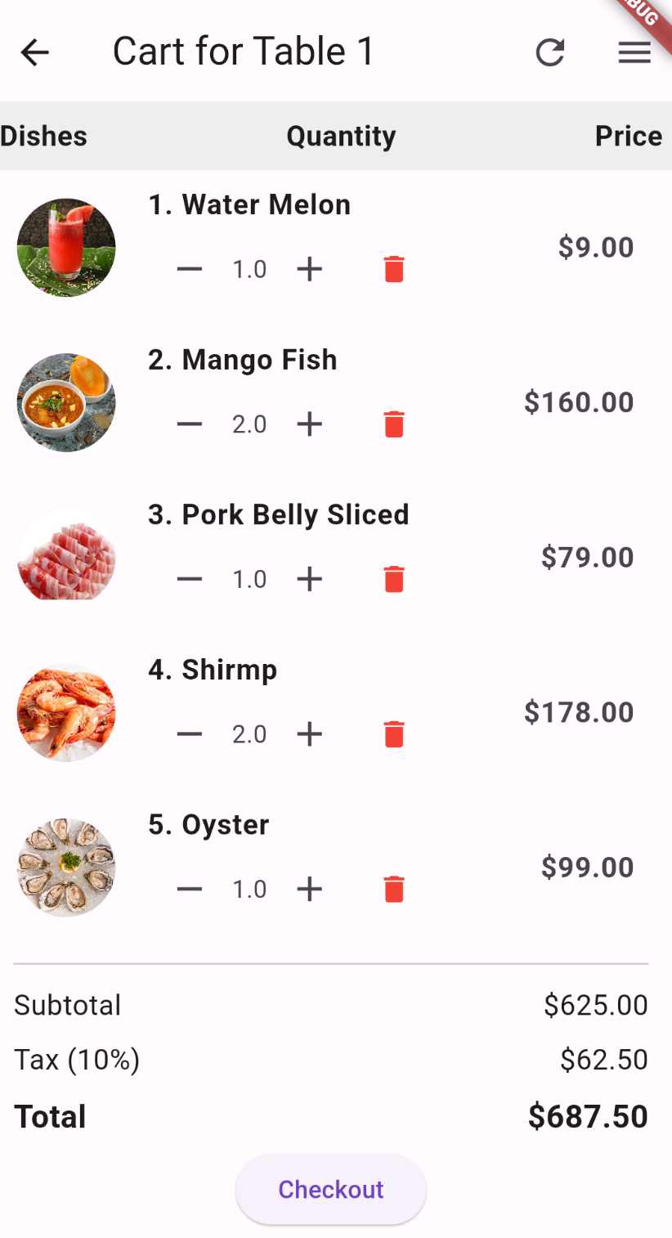

|  |  |  |
| --- | --- | --- |
| **N.o** | **Name** | **Action** |
| 1 | +/- | Staff can add or minus the quality of dishes |
| 2 | Refresh | Staff can check the newest order |
| 3 | Delete | Staff can delete the dishes |
| 4 | Checkout | Staff can check out this table |

**1.11. Table Screen**

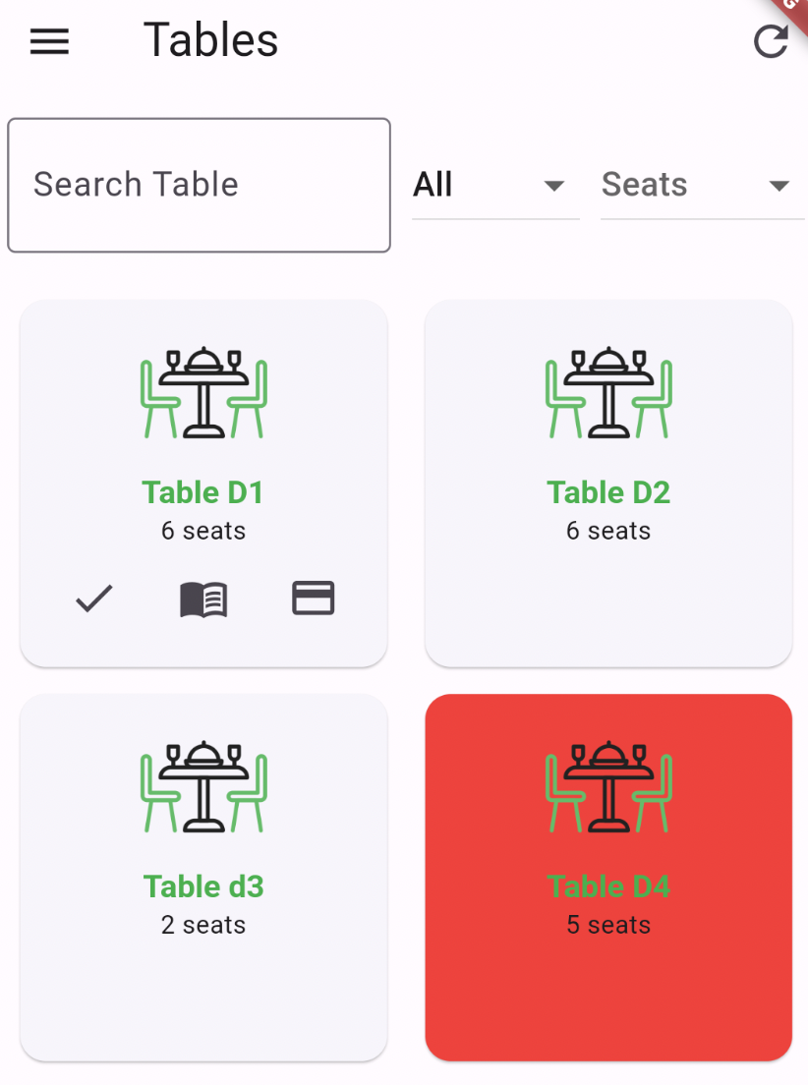

|  |  |  |
| --- | --- | --- |
| **N.o** | **Name** | **Action** |
| 1 | Filter Seats | Staff can filter the tables with seats |
| 2 | Refresh | Staff can check the newest order |
| 3 | Filter by Table | Staff can search serving/available tables |
| 4 | Search | Staff can search the name of table |
| 5 | Check in | Staff can check in the table and the color of the table will change to red color |
| 6 | Menu | Staff can click on the icon menu to open e-menu and add to cart |
| 7 | Cart | Staff can show cart line to customers and move to payment screen |

**1.12. Payment Screen**

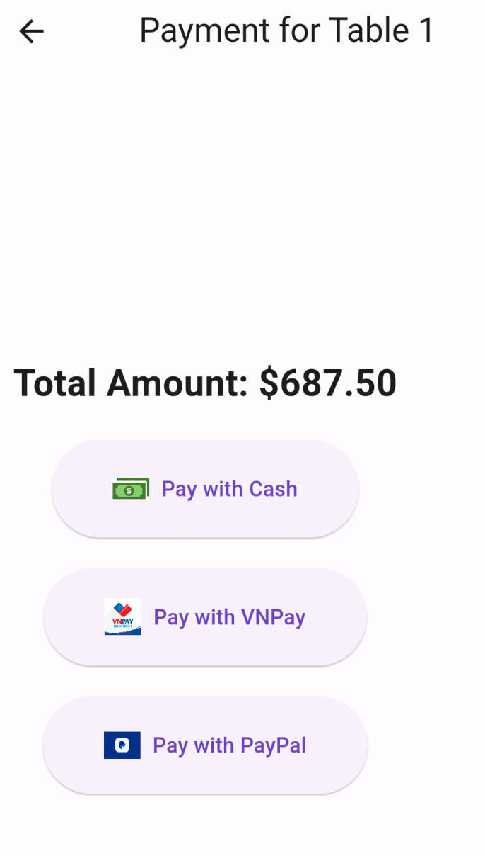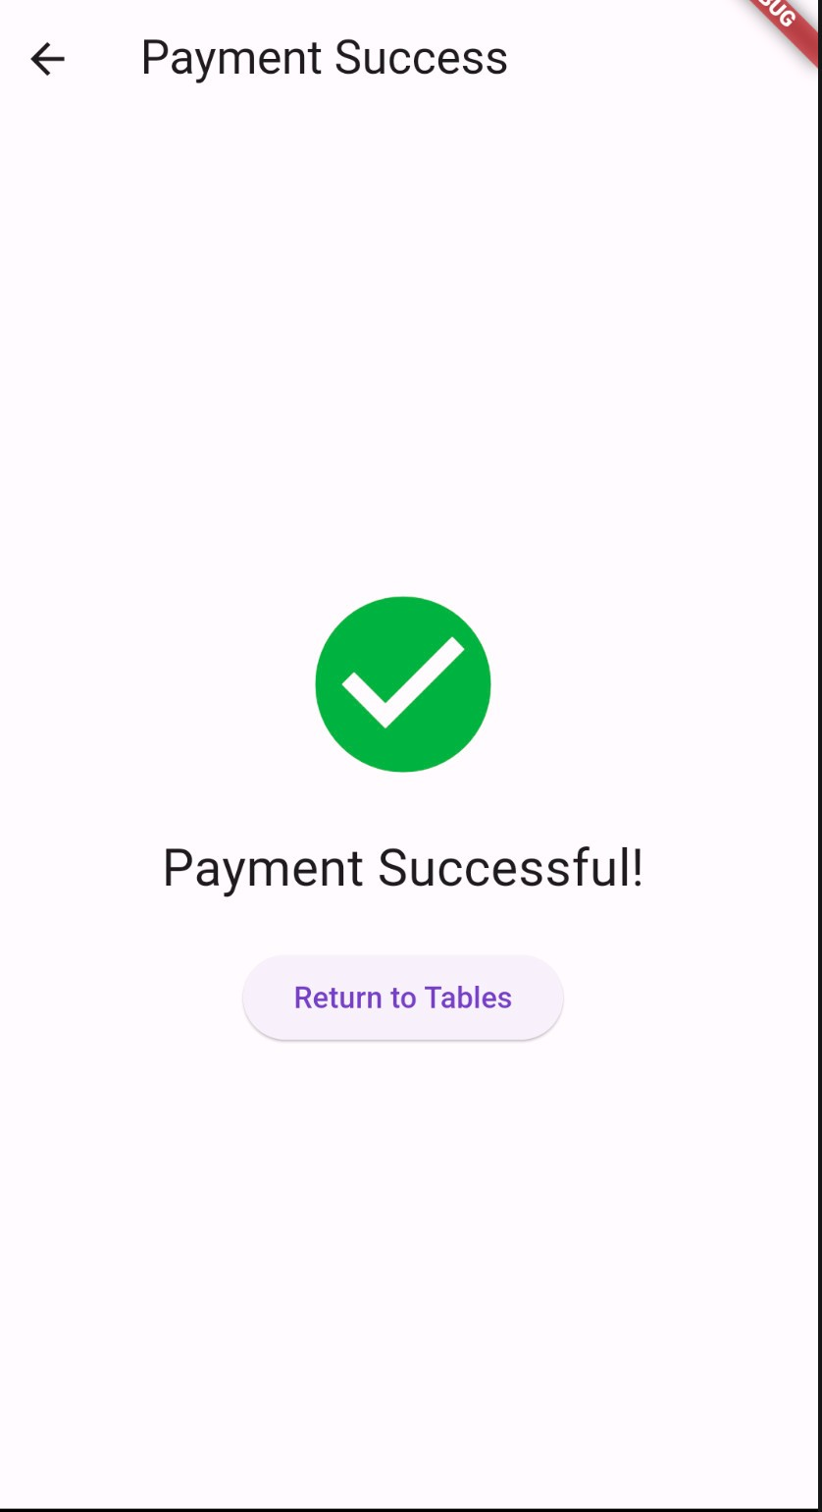

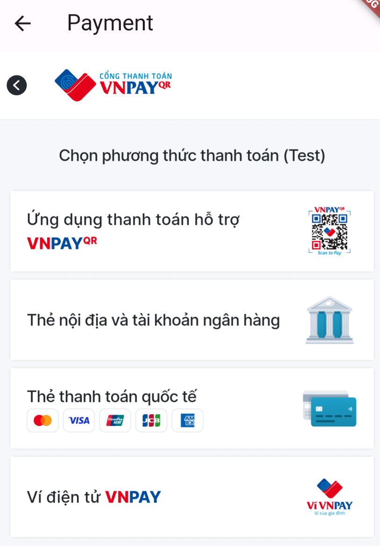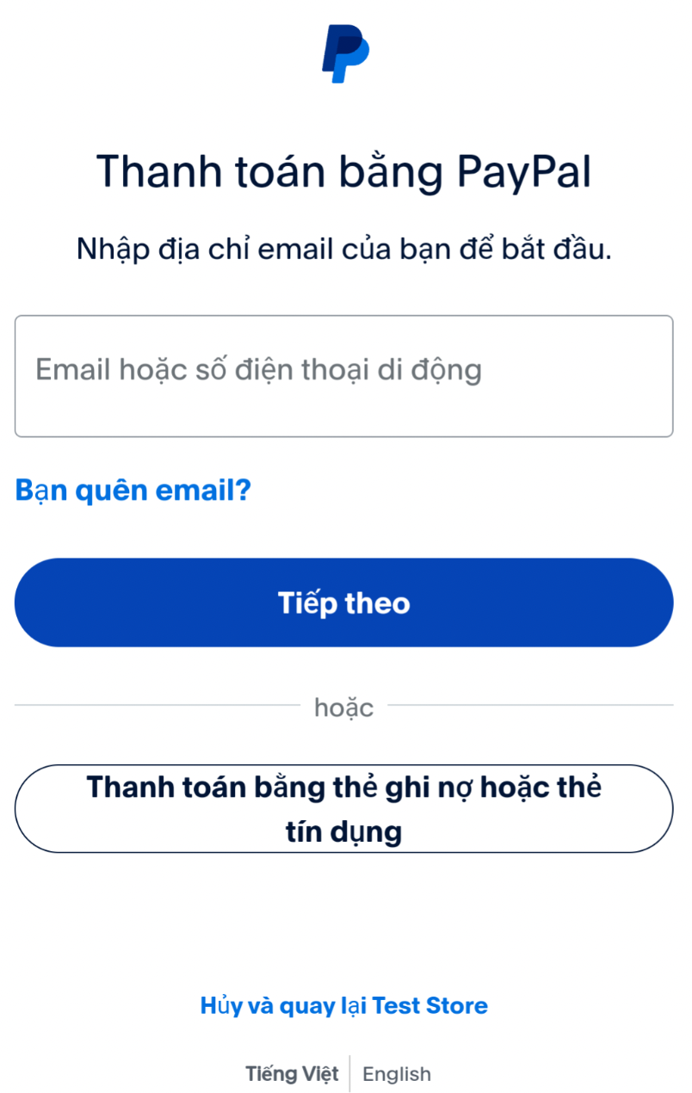

|  |  |  |
| --- | --- | --- |
| **N.o** | **Name** | **Action** |
| 1 | Cash | Customer can pay by cash |
| 2 | VnPay/Paypal | Custoemr can pay by payment methods such as Vnpay or Paypal |

### Booking Table Screen

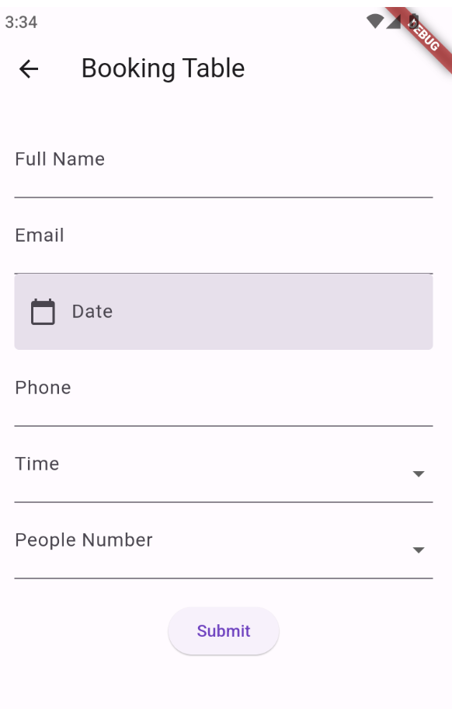

|  |  |  |  |  |  |
| --- | --- | --- | --- | --- | --- |
| **No.** | **Name** | **Validate** | **Type** | **Event** | **Description** |
| 1 | Your name | Required | Textbox | On Type | Input Client name |
| 2 | Your Email Address | Required | Textbox | On Type | Input Client email |
| 3 | Your phone number | Required | Textbox | On Type | Input Client phone |
| 4 | Date | Required | Textbox | On Type | Input Client’s date |
| 6 | Time | Required | Option | Click | Select Client’s time |
| 7 | Person Number | Required | Option | Click | Select person number |
| 8 | Submit | Required | Button | click | Sent messages to Admin/database |

# Task Sheet Review 3

|  |  |  |  |  |  |  |
| --- | --- | --- | --- | --- | --- | --- |
| **Project Title:**  Venus Restaurant | | **Activity Plan**  **Prepared**  **By:** | | **Date of Preparation of Activity Plan:** | | |
| **Sr. No.** | **Task** | **Actual Start**  **Date** | **Actual**  **Days** | **Status** | |
| 1 | Database Design | All | 25/5/2024 | | 1 | Completed | |
| 2 | GUI Design | 25/5/2024 | | 1 | Completed | |
| 3 | Write a report | 25/5/2024 | | 1 | Completed | |
| 4 | Task sheet review | 25/5/2024 | | 1 |  | |
| 6 | **Chef Management** **(Web -Mobile)** (Update Status/ Filter) | QUỐC VINH | 1/6/2024 | | 10 | Completed | |
| 7 | **Blog (Web - Mobile)** *(Create/Edit/View/Delete/Show/Hidden blogs)* | QUỐC VINH | 1/6/2024 | | 10 | Completed | |
| 8 | **About us (Web)** | QUỐC VINH | 1/6/2024 | | 1 | Completed | |
| 9 | **Contact Us (Web - Mobile)** *(Send Message to admin and clients used Thymeleaf templates/ Recapcha)* | QUỐC VINH | 1/6/2024 | | 10 | Completed | |
| 10 | **Order Status (Mobile)** *(Show oderstatus/ Filter by table or status)* | QUỐC VINH | 1/6/2024 | | 10 | Completed | |
| 11 | **Index (Web)** *(Show dishes/blogs/ Search dishes)* | QUỐC VINH | 1/6/2024 | | 1 | Completed | |
| 12 | **Login (Mobile)** | QUỐC VINH | 1/6/2024 | | 2 | Completed | |
| 13 | **Logout (Mobile)** | QUỐC VINH | 1/6/2024 | | 2 | Completed | |
| 14 | **Ingredient manangement** | Tiến | 15/03/2024 | | 5 | Completed | |
| 15 | **Inventory manangement** | Tiến | 20/03/2024 | | 5 | Completed | |
| 16 | **Sign up for a table reservation (Web - Mobile)**  *(Create an application and send it to admin/users)* | PHƯỚC | 15/3/2024 | | 10 | Completed | |
| 17 | **Reservation Management (Web)**  *(Manage tables, approve table orders, send notification emails, manage approval orders)* | PHƯỚC | 15/3/2024 | | 10 | Completed | |
| 18 | **Table Management (Web -Mobile)**  ***(****Manage tables,Add, delete, and edit)* | QUỐC VINH | 1/6/2024 | | 1 | Completed | |
| 19 | **Show List Table-Check inTable (Web- Mobile)** | QUỐC VINH | 5/6/2024 | | 2 | Completed | |
| 20 | **Add Menu - Item (Web)**  **edit, and delete menu items.** | Tiến | 04/03/2024 | | 1 | Completed | |
| 23 | **Checkout -Payment methods (Web-Mobile) via PayPal , VN Pay or cash.** | QUỐC VINH | 10/06/2014 | | 1 | Completed | |
| 24 | **Displaying the list of orders(ADMIN) -**  **(ADMIN can view the details of the order list and export invoices to PDF.")** |  | 15/03/2014 | | 1 | Completed | |
| 27 | **List(Mobile) List Disher**  **Add To CartLine** | Tiến | 21/03/2024 | | 3 | Complete | |
| 28 | **Admin: Login** | Hào | 02/03/2024 | | 1 | Complete | |
| 29 | **Admin: Main Page** | Hào | 02/03/2024 | | 3 | Completed | |
| 29 | **Admin: Create Admin** | Hào | 02/03/2024 | | 3 | Completed | |
| 30 | **Admin: User List** | Hào | 03/03/2024 | | 2 | Completed | |
| 31 | **Admin: Edit Personal Details** | Hào | 03/03/2024 | | 2 | Completed | |
| 32 | **Admin: User/Details** | Hào | 05/03/20234 | | 3 | Completed | |
| 33 | **User: Login** | Hào | 06/03/2024 | | 2 | Completed | |
| 34 | **User: Create Account** | Hào | 06/03/2024 | | 3 | Completed | |
| 36 | **User Profile (Mobile)** | Hào | 10/03/2024 | | 5 | Completed | |
| 37 | **Edit User Profile (Mobile)** | Hào | 10/03/2024 | | 5 | Completed | |
| 38 | **Home (moblie)** | Tiến | 25/03/2024 | | 3 | Completed | |

|  |  |
| --- | --- |
| **Signature of Instructor**    **Mr. Hoang Duc Quang** | **Signature of Team Leader** |